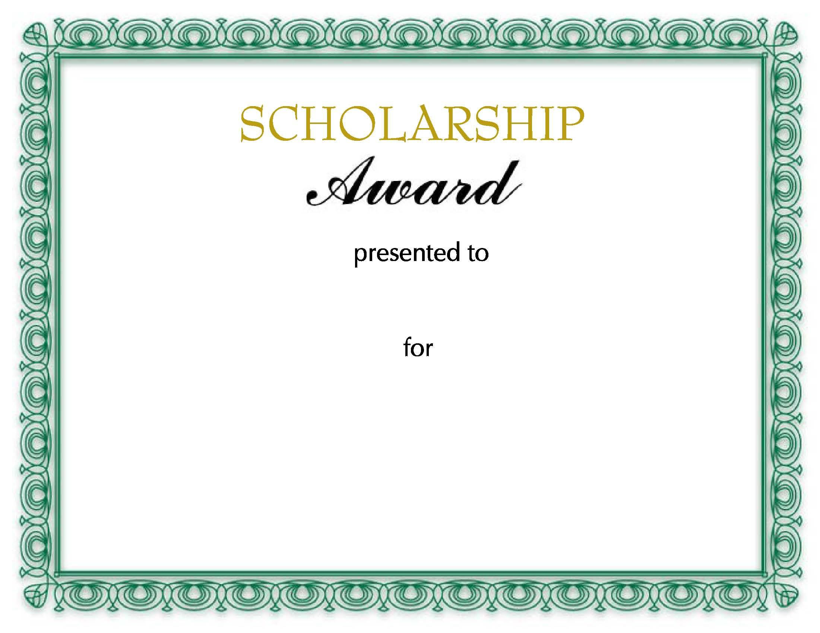

Mr.ABDUULAH

GRADUTION

