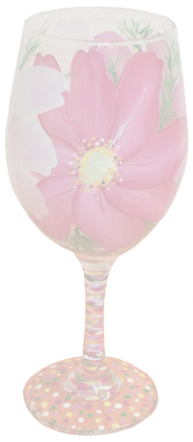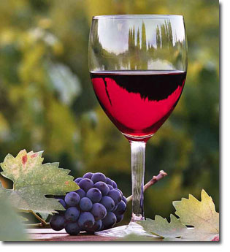

**Wine Menu List**

Wine Menu

**Sparkling Champagne Glass Bottle**

Louis Renderer…………………………………………………………………………… $225.00  
Dom Prignon Vintage…………………………………………………………………. $220.00  
Rotary Brut…………………………………………………………………………………. $26.00  
Wycliff Brut…………………………………………………………………….$40.00 $18.00  
  
**Ports**

Benjamin Tanny Port…………………………………………………………….…… $48.00  
Corckbun Ruby Porto………………………………………………………………….. $24.50  
Churchil’s Finest Vintage…………………………………………………………….. $30.00

**Premium Pours**

HennesyXO Cognac………………………………………………………..………… $33.00  
Rummy Martin 1738……………………………………………………………...…… $20.50