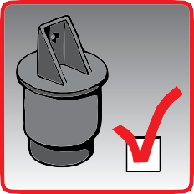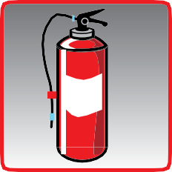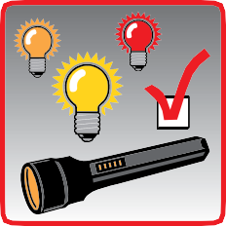

**Vehicle checks must be performed regularly by all drivers to avoid preventable incidents and accidents. The UICR and IRU have put together this checklist to assist drivers in ensuring adequate state of their vehicle.**

**CAR, TRUCK OR VEHICLE CHECKLIST**

**For Drivers**

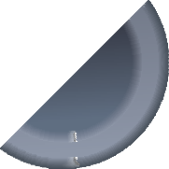

**Emergency Equipment**

**Be prepared and don’t begin a journey without appropriate emergency equipment!**

First aid Kit

Emergency Vest

Warning Triangle

Fire Extinguisher

**Lights & Devices**

**Ensure all lights and on-board devices are properly working before the journey!**

Front, rear, and indicator lights

Side lights, warning lights, and reflectors

Spare lightbulbs, fuses, and flashlight onboard

Recording devices such as Tachograph, gpS, etc

**WHEELS & Suspension Systems**

**Make sure that the wheels and suspension systems are in proper conditions!**

**1x**

**1x**

Check tyre profile and absence of damage (eg punctures)

Check tyre pressure and ensure bolts are tightened

Check suspension system

Check for a spare wheel and at least one wheel chock per vehicle

*Always refer to your vehicle’s owner’s manual and relevant national legislation

**6:00 0km/h**

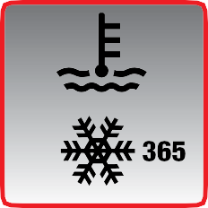

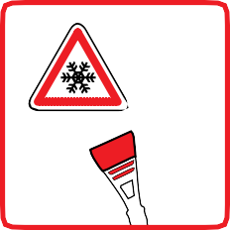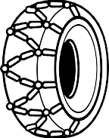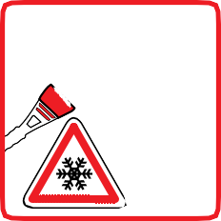

**Fluids**

**Check for the correct level of fluids before the journey as indicated by the manufacturer!**

**OIL**

Check for leaks!

oil

Coolant

Windshield Liquid

**Connections**

**Check your vehicle’s connections before your journey!**

air and power connections

Landing legs

Fifth wheel and kingpin

Battery, alternator and starter

**Load Securing And Security**

**Check for your load’s securing and vehicle’s security before your journey!**

Check that the transport unit is locked or properly sealed (TIR)

Check that the load is properly secured

Check that the curt insider is properly fastened

Check that the transport unit is not damaged

**Precautions In Winter**

**Pay special attention in difficult meteorological conditions!**

de-Ice Windshield

Remove snow and ice from vehicle

Remove snow from the front grill and the distance control unit

Use appropriate winter equipment

**12 V**