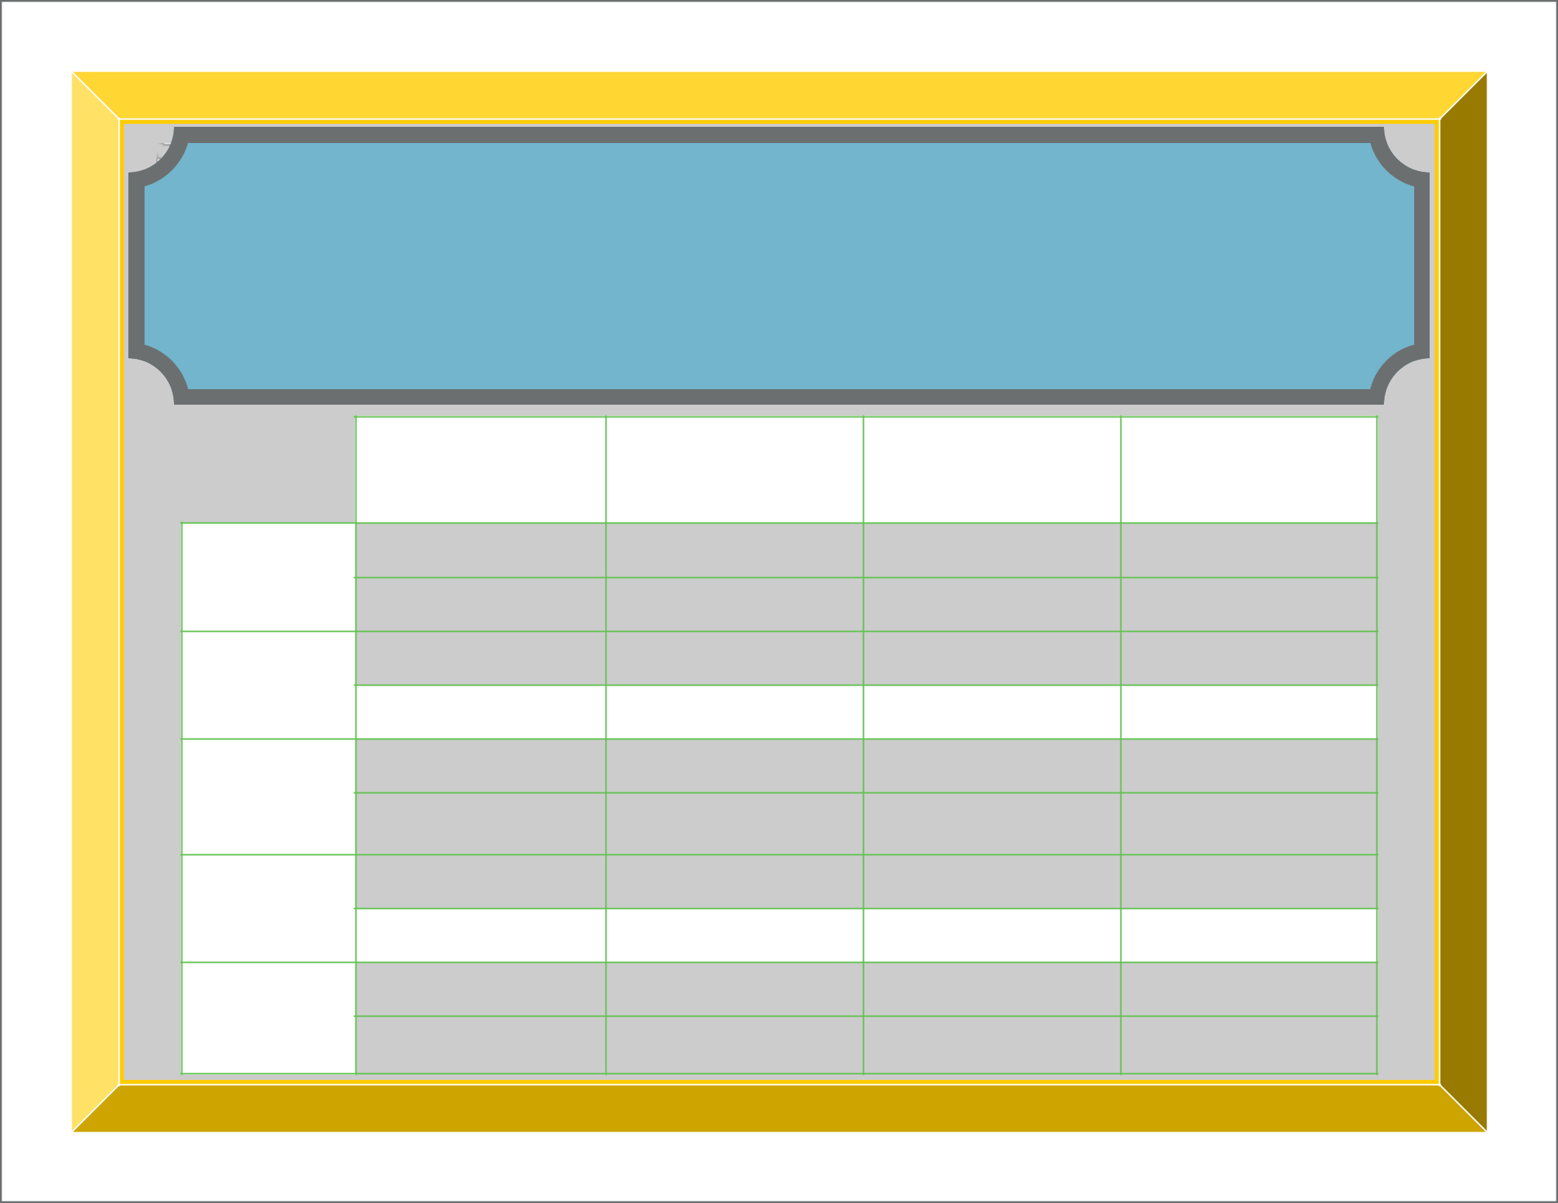
Our Family’s
Five Year Plan & Dreams

1 Year

3 Year

5 Year

Dream Big

Everyday

Wealth

Wellness

Home

Fun

