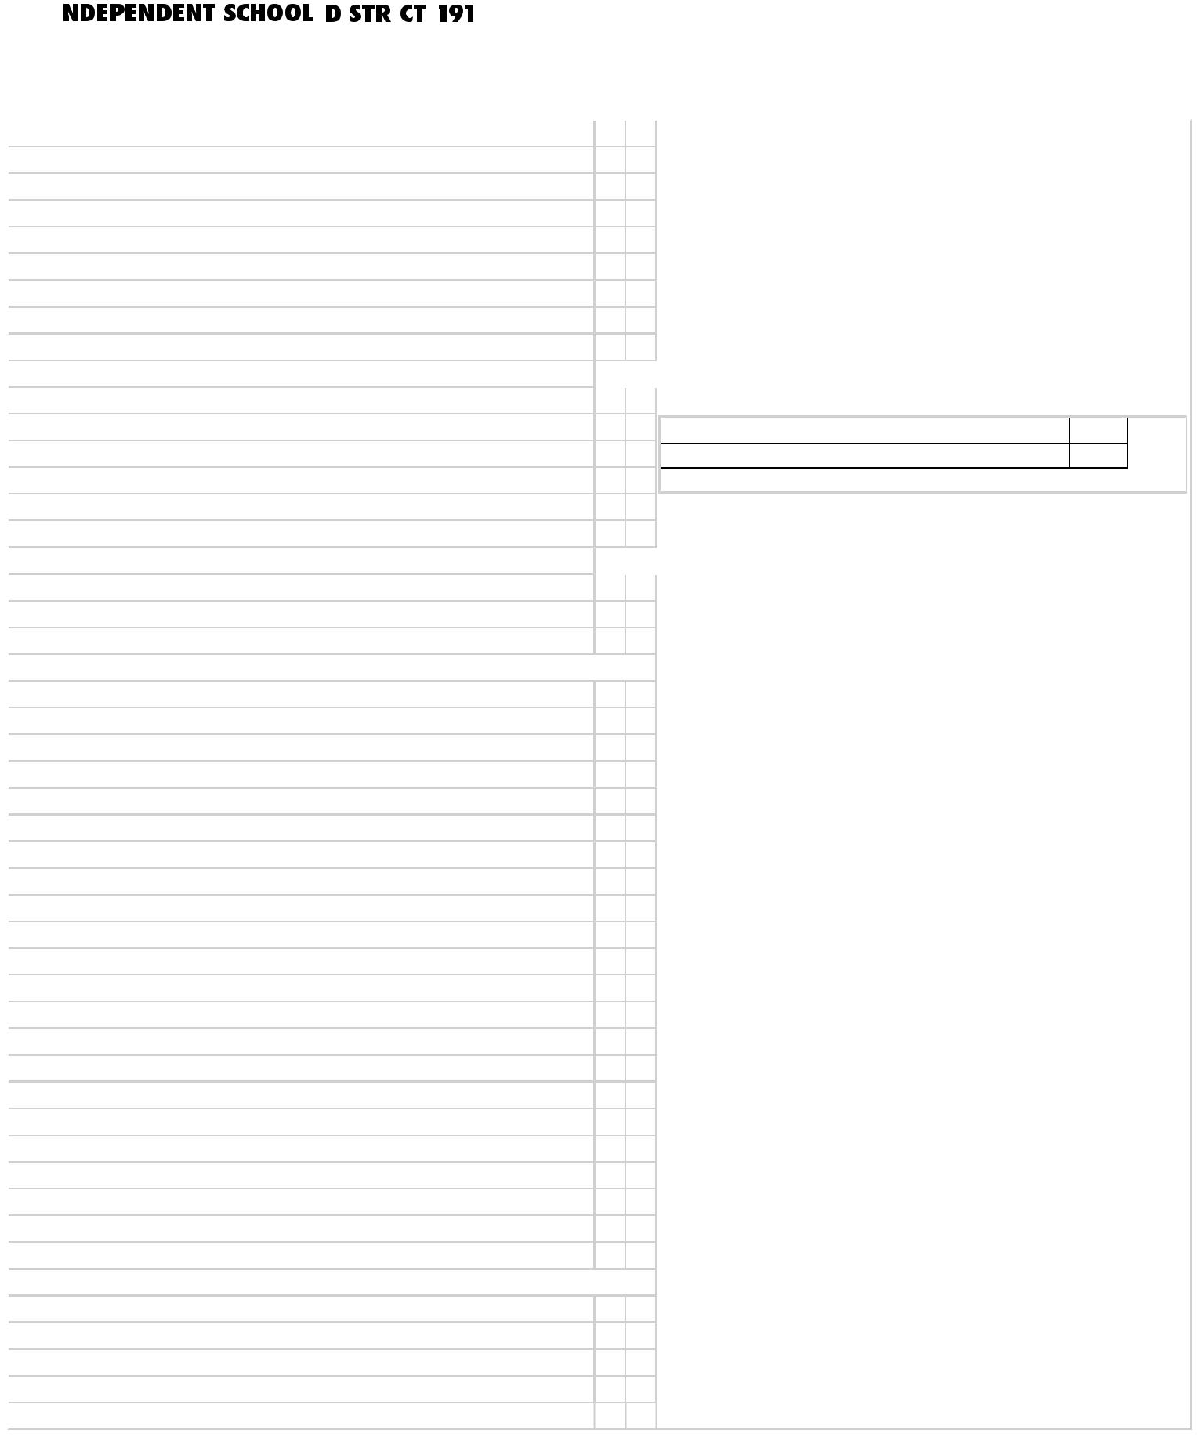
School Report Card

Student Name: |  | SCHOOL REPORT CARD TEMPLATE School Year: 2021-2022
Grade: 06 |  | Homeroom Teacher:

Subject

READING Teacher:

Comprehension

Vocabulary

Independent reading

Reading at grade level

WRITING Teacher:

Elements of composition

Grammar and usage

SPELLING

MATHEMATICS

Numbers and operations/ computation Algebra

Geometry and measurement Probability and statistics
S1 S2 _{Key}

_ (Academic Scale)

- (90-100)

- (80-89)

- (70-79)

- (60-69)

- (59-0)

__ (Standards and Personal Development Scale) 4 (Exceeding the Standard)
3 (Meeting the Standard)

2 (Progressing Towards the Standard)  1 (Not meeting the Standard)

Grading Period | 1 | 2
Days Absent | 0.00 | 0.00
Days Tardy | 0.00 | 0.00

SCIENCE

Scientific processes (connection, nature of science, inquiry, application)  Scientific concepts ( Life, Earth & Space, Physical)

SOCIAL STUDIES

HEALTH

PERSONAL DEVELOPMENT/STUDY SKILLS/EFFORT

Respects others

Follows school rules

Accepts responsibility for behavior

Listens and follows directions

Works independently

Organizes work and materials

Completes class work/homework on time

ART

Concepts/skills

Effort/participation

MUSIC Teacher:

Reading,writing, & demonstrating rhythmic notation

Singing

Effort/participation

PHYSICAL ED Teacher:

Movement skills

Participation

Self-control

SCIENCE SPECIALIST Teacher:

Scientific concepts

Scientific skills and process

Effort/participation

SERVICES RECEIVED Teacher: Certified Staff .

English as a Second Language (ESL)

Enrichment Program

Individual Education Program (IEP)

Section 504 Accommodation Plan

Title I

NOTE: This is a sample report card for grades 4 through 6

