
School Year: 2021-2022
School Report Card

Student Name: ____________________________________ ID# ________________

School: ____________________________ Grade: _______________________

Purpose of Report:

This report is designed to inform you about your student’s progress toward achieving the North Carolina Essential Standards and/or the Common Core State Standards. The Standards establish high and challenging expectations for all students, and describe what students should know and be able to do by the end of the academic year. This report card is a working document which is reflective of your child’s progress at the time of issue. The objectives contained within this document are reflective of skills to be mastered by the end of the 2012 - 2013 school year. They serve as the basis for kindergarten curriculum, instruction, and assessment in Charlotte-Mecklenburg Schools. This report cannot communicate everything you might want to know about your child’s current progress. This report should be considered with other information you receive from the school concerning your child’s academic progress. Regular communication between the family and the school staff is highly encouraged. The comments section indicates grade level performance based upon academic level and accommodations if appropriate. Level 3 is considered proficient. If you have any questions or concerns, please contact your child’s teacher or counselor.

This document serves as a PEP for those students at risk for not reaching grade level proficiency by the end of the year. Specific Areas of Need are indicated

QTR 1 Comments:

QTR 2 Comments:

QTR 3 Comments:

QTR 4 Comments:

Attendance | Quarter 1 |  | Quarter 2 |  | Quarter 3 |  | Quarter 4 |  | Year
 | (_____to_____) |  | (_____to_____) |  | (_____to_____) |  | (_____to_____) |  | (_____to_____)
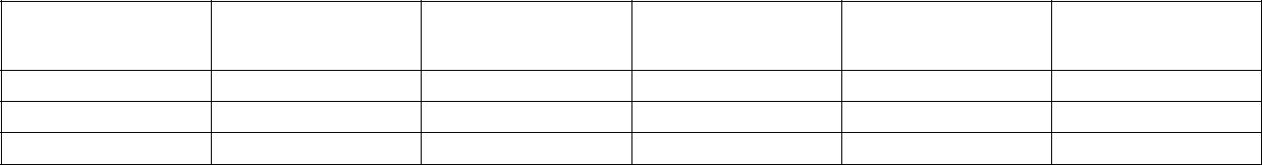
Absent

Tardy

Days Present
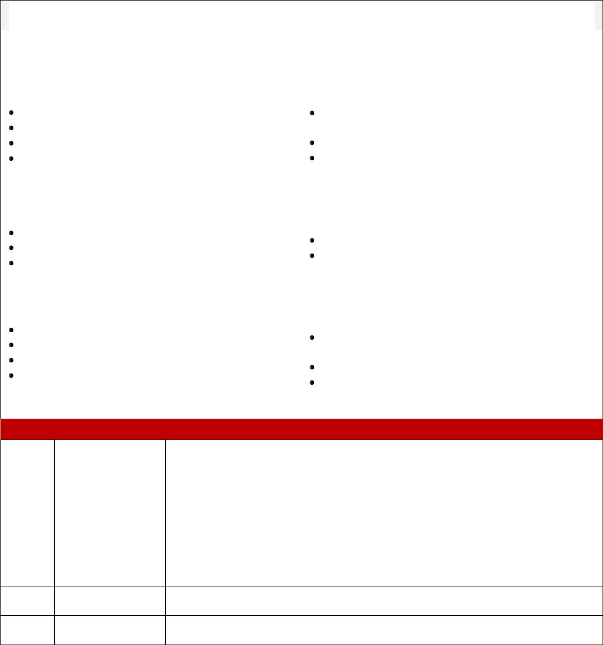

General Learner Outcomes (GLOs): The six General Learner Outcomes are the essential goals of learning for students.

 | GLO Ratings: |  |  |  |  |  |  | 3 = Consistently |  |  |  |  |  |  |  | 2 = Sometimes | 1 = Rarely
 | General Learner Outcomes |  |  | Q1 |  |  | Q2 |  |  | Q3 |  |  | Q4 |  |  | General Learner Outcomes |  |  | Q1 |  |  | Q2 |  |  | Q3 |  |  | Q4
 | (GLOs) |  |  | Q1 |  |  | Q2 |  |  | Q3 |  |  | Q4 |  |  | (GLOs) |  |  | Q1 |  |  | Q2 |  |  | Q3 |  |  | Q4
 | GLO 1: Self Directed Learner |  |  |  |  |  |  |  |  |  |  |  |  |  |  | GLO 2: Community
 | GLO 1: Self Directed Learner |  |  |  |  |  |  |  |  |  |  |  |  |  |  | Contributor
 | The ability to be responsible for one’s own learning. |  |  |  |  |  |  |  |  |  |  |  |  |  |  | The understanding that it is essential to work together.
 | Works independently and asks for help when needed |  |  |  |  |  |  |  |  |  |  |  |  |  |  | Participates cooperatively and appropriately with others to
 | Organizes workplace and materials |  |  |  |  |  |  |  |  |  |  |  |  |  |  | achieve shared goals
 | Makes productive use of class time |  |  |  |  |  |  |  |  |  |  |  |  |  |  | Shows respect and recognizes the feelings of others
 | Sets Goals |  |  |  |  |  |  |  |  |  |  |  |  |  |  | Follows school and classroom rules
 | GLO 3: Complex Thinker |  |  |  |  |  |  |  |  |  |  |  |  |  |  | GLO 4: Quality Producer
 | The ability to demonstrate critical thinking and problem- |  |  |  |  |  |  |  |  |  |  |  |  |  |  | The ability to recognize and produce quality performance
 | solving strategies
 | solving strategies |  |  |  |  |  |  |  |  |  |  |  |  |  |  | and quality products
 | Uses prior knowledge and experiences to solve problems |  |  |  |  |  |  |  |  |  |  |  |  |  |  | and quality products
 |  |  |  |  |  |  |  |  |  |  |  |  |  |  |  | Strives to complete work neatly and correctly
 | Explains answers and makes adjustments
 |  |  |  |  |  |  |  |  |  |  |  |  |  |  |  | Sets and strives toward learning goals
 | Solves problems in different ways
 | GLO 5: Effective |  |  |  |  |  |  |  |  |  |  |  |  |  |  | GLO 6: Effective/Ethical User
 | Communicator |  |  |  |  |  |  |  |  |  |  |  |  |  |  | of Technology
 | The ability to communicate effectively |  |  |  |  |  |  |  |  |  |  |  |  |  |  | The ability to effectively and ethically use a variety of
 |  |  |  |  |  |  |  |  |  |  |  |  |  |  |  | technologies
 | Speaks effectively in front of a group |  |  |  |  |  |  |  |  |  |  |  |  |  |  | technologies
 |  |  |  |  |  |  |  |  |  |  |  |  |  |  |  | Uses school materials/tools properly (e.g. books, TV, DVD,
 | Listens attentively to gain understanding
 |  |  |  |  |  |  |  |  |  |  |  |  |  |  |  | computers, art supplies, pencils, scissors, glue, etc.)
 | Follows directions
 | Follows directions |  |  |  |  |  |  |  |  |  |  |  |  |  |  | Explains how technology is used every day
 | Contributes effectively through speaking, drawing, and
 |  |  |  |  |  |  |  |  |  |  |  |  |  |  |  | Uses various technologies responsibly to find information
 | writing
 | writing |  |  |  |  |  |  |  |  |  |  |  |  |  |  | and create new products
CMS Kindergarten, First, Second Grade Report Card Rubric

4 | Expands Grade | Indicates the student consistently produces high quality work, applies concepts
4 | Level Standards | independently, and is self-motivated.
 |  | Indicates the student consistently meets grade level standards. The student regularly
 | Meets Grade Level | demonstrates proficiency in the majority of the standards for the current grade level. The
3 | Meets Grade Level | student, with limited errors, grasps and applies key concepts, processes and skills for the
3 | Standards
 | Standards | current grade. An * next to a standard indicates that level 3 is the highest level of proficiency
 |  | possible.
 | Progressing | Indicates the student is approaching and occasionally meets the standards for the current
2 | Toward Grade | grade level. The student is beginning to grasp and apply key concepts, processes, and
 | Level Standards | skills for the current grade level.

- Not Meeting Grade Indicates the student has not yet met minimum level standards. The student needs more Level Standards time, experience, and possible intervention for concepts, processes and skills to develop.

N/A | Not Assessed At | These standards have not been addressed at this time. However, standards will be
N/A | This Time | introduced before the end of the school year.

 |  | Reading Standards for |  |  | Q1 |  |  | Q2 |  |  | Q3 |  |  | Q4 |  |  | Reading Standards for |  |  |  |  | Q1 |  |  |  | Q2 |  |  | Q3 |  |  | Q4
 |  | Literature |  |  | Q1 |  |  | Q2 |  |  | Q3 |  |  | Q4 |  |  | Informational Text |  |  |  |  |  |  |  |  | Q2 |  |  | Q3 |  |  | Q4
 |  | Key Ideas and Details |  |  |  |  |  |  |  |  |  |  |  |  |  |  | Key Ideas and Details
 |  | With prompting and support… |  |  |  |  |  |  |  |  |  |  |  |  |  |  | With prompting and support…
 |  |  |  |  |  |  |  |  |  |  |  |  |  |  |  |  | …asks and answers questions about key details in a text.
 |  | …asks and answers questions about key details in a text.
 |  |  |  |  |  |  |  |  |  |  |  |  |  |  |  |  | …identifies the main topic and retells key details of a text.
 |  | …retells familiar stories, including key details.
 |  |  |  |  |  |  |  |  |  |  |  |  |  |  |  |  | …describes the connection between two individuals, events, ideas,
 |  | …identifies characters, settings, and major events in a story.
 |  |  |  |  |  |  |  |  |  |  |  |  |  |  |  |  | or pieces of information in a text.
 |  | Craft and Structure |  |  |  |  |  |  |  |  |  |  |  |  |  |  | Craft and Structure
 |  |  |  |  |  |  |  |  |  |  |  |  |  |  |  |  | With prompting and support, asks and answers questions about
 |  | Asks and answers questions about unknown words in a text. |  |  |  |  |  |  |  |  |  |  |  |  |  |  | unknown words in a text.
 |  | Recognizes common types of texts (e.g., storybooks, poems). |  |  |  |  |  |  |  |  |  |  |  |  |  |  | Identifies the front cover, back cover, and title page of a book.
 |  | With prompting and support, names the author and illustrator of |  |  |  |  |  |  |  |  |  |  |  |  |  |  | Names the author and illustrator of a text and defines the role of
 |  | a story and defines the role of each in telling the story. |  |  |  |  |  |  |  |  |  |  |  |  |  |  | each in presenting the ideas or information in a text.
 |  | Integration of Knowledge and |  |  |  |  |  |  |  |  |  |  |  |  |  |  | Integration of Knowledge and
 |  | Ideas |  |  |  |  |  |  |  |  |  |  |  |  |  |  | Ideas
 |  | With prompting and support… |  |  |  |  |  |  |  |  |  |  |  |  |  |  | With prompting and support,
 |  | …describes the relationship between illustrations and the story in |  |  |  |  |  |  |  |  |  |  |  |  |  |  | …describes the relationship between illustrations and the text in
 |  | which they appear (e.g., what moment in a story an illustration |  |  |  |  |  |  |  |  |  |  |  |  |  |  | which they appear (e.g., what person, place, thing, or idea in the
 |  | depicts). |  |  |  |  |  |  |  |  |  |  |  |  |  |  | text an illustration depicts).
 |  | …compares and contrasts the adventures and experiences of |  |  |  |  |  |  |  |  |  |  |  |  |  |  | …identifies the reasons an author gives to support points in a text.
 |  | characters in familiar stories. |  |  |  |  |  |  |  |  |  |  |  |  |  |  | ...identifies basic similarities in and differences between two texts
 |  |  |  |  |  |  |  |  |  |  |  |  |  |  |  |  | on the same topic (e.g., in illustrations, descriptions, or
 |  |  |  |  |  |  |  |  |  |  |  |  |  |  |  |  | procedures).
 |  | Range of Reading and Level of |  |  |  |  |  |  |  |  |  |  |  |  |  |  | Range of Reading and Level of
 |  | Text Complexity |  |  |  |  |  |  |  |  |  |  |  |  |  |  | Text Complexity
 |  | Actively engages in group reading activities with purpose and |  |  |  |  |  |  |  |  |  |  |  |  |  |  | Actively engages in group reading activities with purpose and
 |  | understanding. |  |  |  |  |  |  |  |  |  |  |  |  |  |  | understanding.
 |  | Speaking and Listening Standards |  |  |  |  |  |  |  |  |  |  |  |  |  |  |  | Q1 |  | Q2 |  |  |  |  | Q3 |  |  |  |  | Q4
 |  | Comprehension and Collaboration
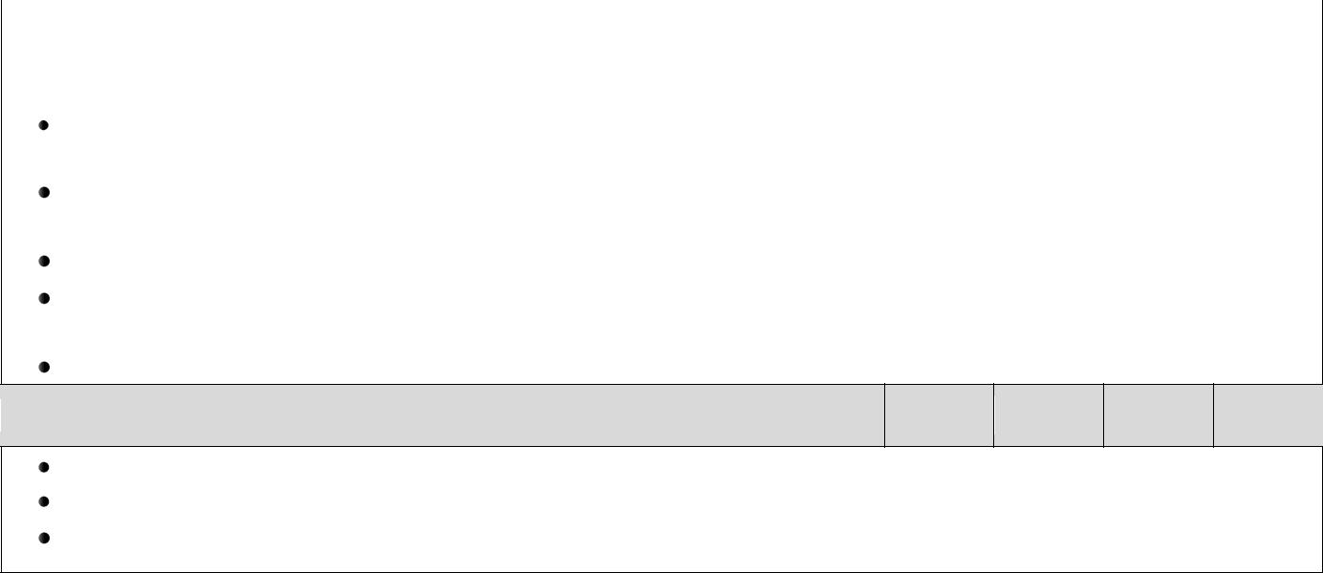

Participates in collaborative conversations with diverse partners about kindergarten topics and texts with peers and adults in small and larger groups.

Follows agreed-upon rules for discussions (e.g., listening to others and taking turns speaking about the topics and texts under discussion).

Continues a conversation through multiple exchanges.

Confirms understanding of a text read aloud or information presented orally or through other media by asking and answering questions about key details and requesting clarification if something is not understood.

Asks and answers questions in order to seek help, get information, or clarify something that is not understood.

Presentation of Knowledge and Ideas

Describes familiar people, places, things, and events and, with prompting and support, provides additional detail. Adds drawings or other visual displays to descriptions as desired to provide additional detail.

Speaks audibly and expresses thoughts, feelings, and ideas clearly.

Reading Standards: Foundational Skills |  | Q1 |  | Q2 |  | Q3 |  | Q4
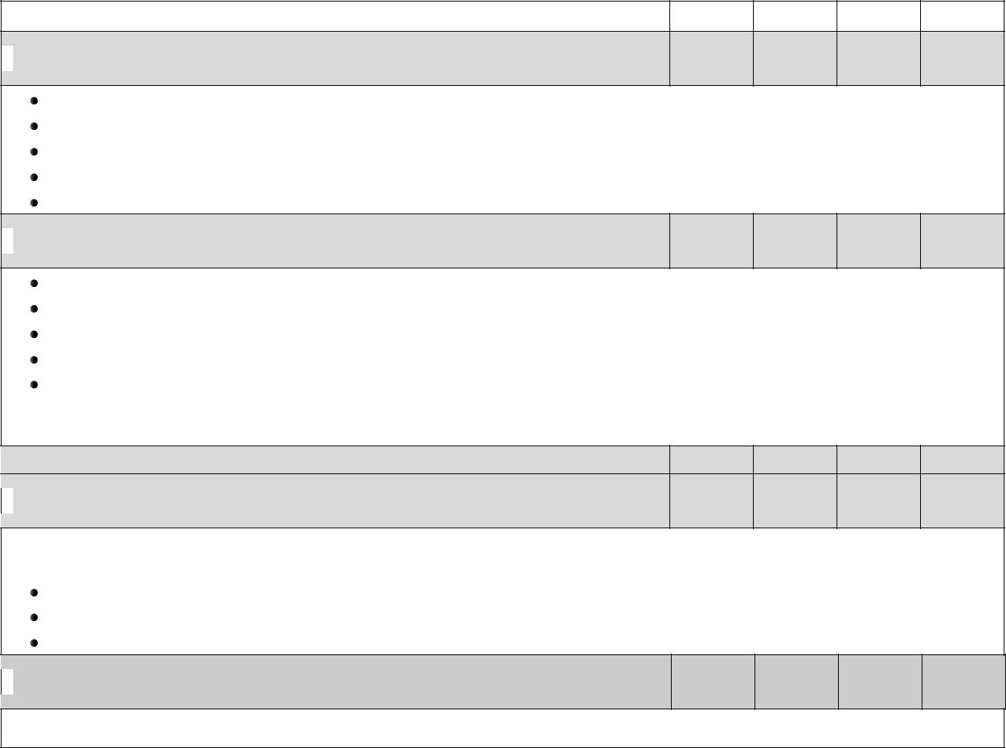
Print Concepts

Demonstrates understanding of the organization and basic features of print. Follows words from left to right, top to bottom, and page by page.

Recognizes that spoken words are represented in written language by specific sequences of letters. Understands that words are separated by spaces in print.

Recognizes and names all upper – and lowercase letters of the alphabet.

Phonological Awareness

Demonstrates understanding of spoken words, syllables, and sounds (phonemes). Recognizes and produces rhyming words.

Counts, pronounces, blends, and segments syllables in spoken words. Blends and segments onsets and rimes of single-syllable spoken words.

Isolates and pronounces the initial, medial vowel, and final sounds (phonemes) in three-phoneme (consonant-vowel-consonant, or CVC) words. (This does not include CVCs ending with /I/, /r/, or /x/.)
Adds or substitutes individual sounds (phonemes) in simple, one-syllable words to make new words.

Phonics and Word Recognition

Demonstrates basic knowledge of letter-sound correspondence by producing the primary or most frequent sound for each consonant.

Associates the long and short sound with the common spelling (graphemes) for the five major vowels. Reads common high-frequency words by sight ( e.g., the, of, to, you, she, my, is, are, do, does). Distinguishes between similarly spelled words by identifying the sounds of the letters that differ.

Fluency

Reads emergent-reader texts with purpose and understanding.
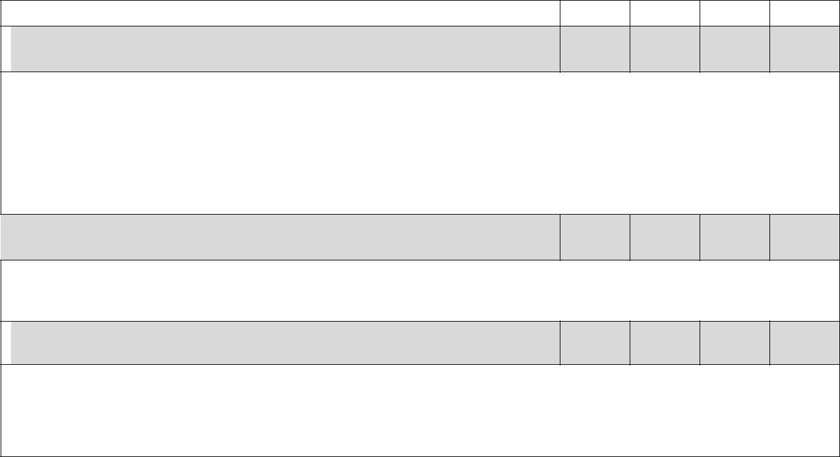
Writing Standards |  | Q1 |  | Q2 |  | Q3 |  | Q4
Text Types and Purposes

Uses a combination of drawing, dictating, and writing

…to compose opinion pieces in which they tell a reader the topic or the name of the book they are writing about and state an opinion or preference about the topic or book.

…to compose informative/explanatory texts in which they name what they are writing about and supply some information about the topic.

…to narrate a single event or several loosely linked events, tell about the events in the order in which they occurred, and provide a reaction to what happened.

Production and Distribution of Writing

With guidance and support from adults,

… responds to questions and suggestions from peers and adds details to strengthen writing as needed. …explores a variety of digital tools to produce and publish writing, including in collaboration with peers.
Research to Build and Present Knowledge

Participates in shared research and writing projects (e.g., explore a number of books by a favorite author and express opinions about them).
With guidance and support from adults, recalls information from experiences or gathers information from provided sources to answer a question.
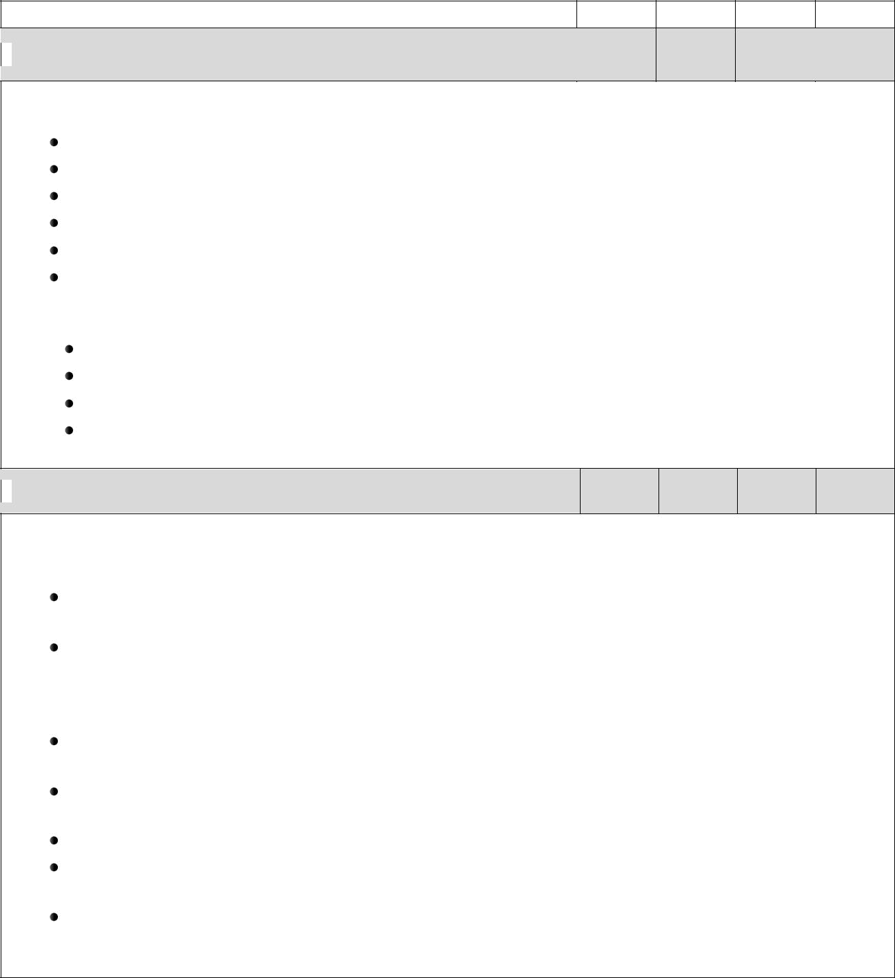  Language Standards | Q1 |  | Q2 |  | Q3 | Q4

Conventions of Standard English

Demonstrates command of the conventions of standard English grammar and usage when writing or speaking: Prints many upper-and lowercase letters.

Uses frequently occurring nouns and verbs.

Forms regular plural nouns orally by adding /s/ or /es/ (e.g., dog, dogs; wish, wishes). Understands and uses question words (interrogatives) e.g., who, what, where, when, why, how). Uses the most frequently occurring prepositions (e.g., to, from, in, out, on, off, for, of, by, with). Produces and expands complete sentences in shared language activities.

Demonstrates command of the conventions of standard English capitalization, punctuation, and spelling when writing: Capitalizes the first word in a sentence and the pronoun I.

Recognizes and names end punctuation.

Writes a letter or letters for most consonant and short-vowel sounds (phonemes). Spells simple words phonetically, drawing on knowledge of sound-letter relationships.

Vocabulary Acquisition and Use

Determines or clarifies the meaning of unknown and multiple-meaning words and phrases based on kindergarten reading and content:

Identifies new meanings for familiar words and applies them accurately (e.g. knowing duck is a bird and learning the verb to duck).

Uses the most frequently occurring inflections and affixes (e.g., -ed, -s, re-, un-, pre-, -ful, -less) as a clue to the meaning of an unknown word.

With guidance and support from adults, explores word relationships and nuances in word meanings:

Sorts common objects into categories (e.g., shapes, foods) to gain a sense of the concepts the categories represent.

Demonstrates understanding of frequently occurring verbs and adjectives by relating them to their opposites (antonyms).

Identifies real-life connections between words and their use (e.g., note places at school that are colorful).

Distinguishes shades of meaning among verbs describing the same general action (e.g. walk, march, strut, prance) by acting out the meanings.

Uses words and phrases acquired through conversations, reading and being read to, and responding to texts.

Kindergarten Social Studies | Q1 | Q2 |  | Q3 |  | Q4
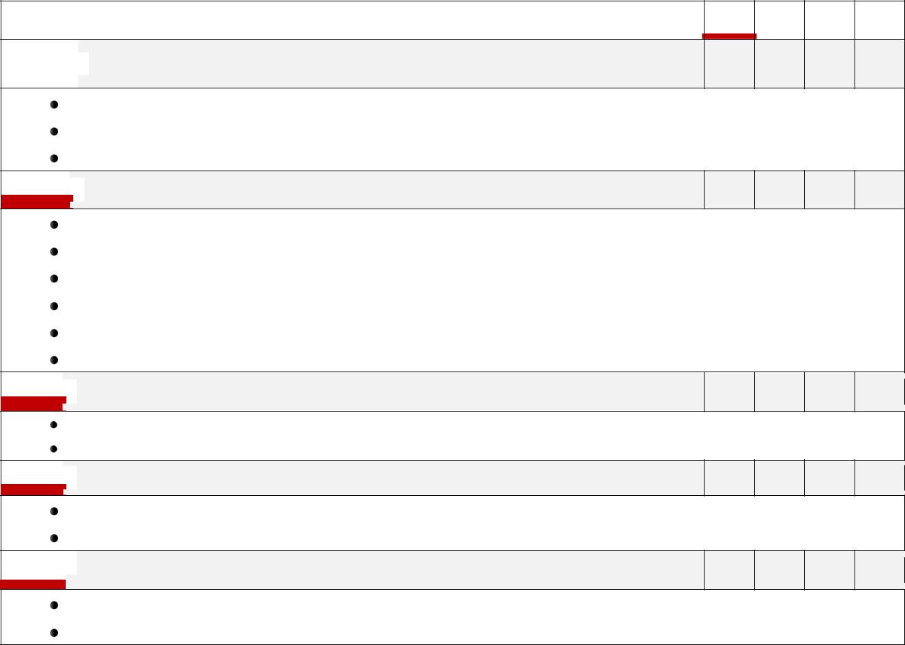
History

Explains how people change over time.

Explain how seasons change over time.

Explains the impact of how life events bring change.
Geography and Environmental Literacy

Uses maps to locate places in the classroom, school and home. Uses globes and maps to locate land and water features.

Identifies physical features (mountains, hills, rivers, lakes, roads, etc.)

Identifies locations in the classroom using positional words (near/far, left/right, above/etc.). Explains how people adapt to weather conditions.

Explains ways people use environmental resources to meet basic needs and wants (shelter, food, clothing, etc.).
Economics and Financial Literacy

Explains how families have needs and wants

Explains how jobs help people meet their needs and wants.
Civics and Governance

Exemplifies positive relationships through fair play and friendship.

Explains why citizens obey rules in the classroom, school, home and neighborhood.
Culture

Explains similarities in self and others.

Explains the elements of culture (how people speak, how people dress, foods they eat, etc.)
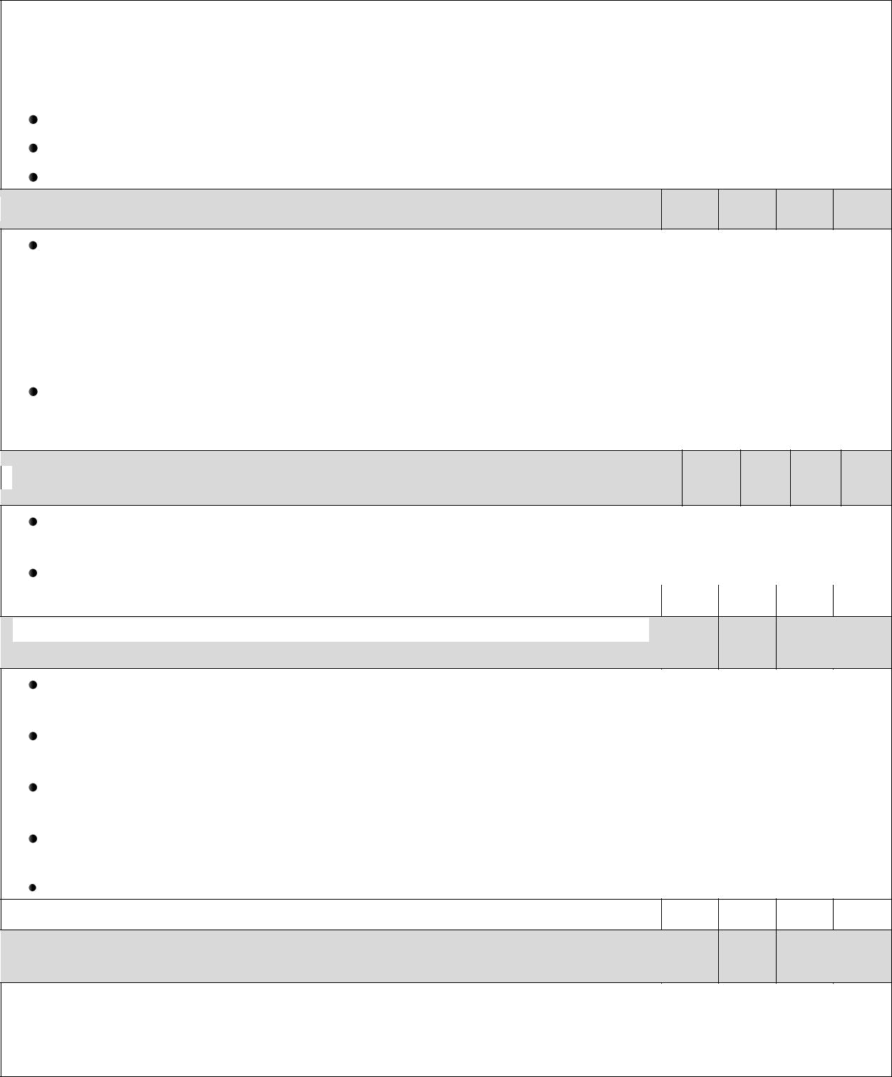
 | MATHEMATICS
 | Counting and Cardinality |  | Q1 | Q2 | Q3 | Q4
 | Knows number names and the count sequence.

Counts to 100 by ones and by tens.

Counts forward beginning from a given number within the known sequence

Represents a number of objects with a written numeral 0-20.

Counts to tell the number of objects

Understands the relationship between numbers and quantities; connects counting to cardinality.

- When counting objects, says the number names in the standard order, pairing each object with one and only one number name and each number name with one and only one object.

- Understands that the last number name said tells the number of objects counted. The number of objects is the same regardless of their arrangement or the order in which they were counted.
- Understands that each successive number name refers to a quantity that is one larger.

Counts to answer ―”how many?“ questions about as many as 20 things arranged in a line, a rectangular array, or a circle, or as many as 10 things in a scattered configuration; given a number from 1–20, counts out that many objects.

Compares numbers

Identifies whether the number of objects in one group is greater than, less than, or equal to the number of objects in another group.

Compares two numbers between 1 and 10 presented as written numerals.

Operations and Algebraic Thinking | Q1 | Q2 | Q3 | Q4

Understands addition as putting together and adding to, and understands subtraction as taking apart and taking from

Represents addition and subtraction with objects, fingers, mental images, drawings, sounds (e.g., claps), and acting out situations, verbal explanations, expressions, or equations.

Solves addition and subtraction word problems, and adds and subtracts within 10, e.g., by using objects or drawings to represent the problem.

Decomposes numbers less than or equal to 10 into pairs in more than one way, e.g., by using objects or drawings, and records each decomposition by a drawing or equation (e.g., 5 = 2 + 3 and 5 = 4 + 1).

For any number from 1 to 9, finds the number that makes 10 when added to the given number, e.g., by using objects or drawings, and records the answer with a drawing or equation.

Fluently adds and subtracts within 5.

Number and Operations in Base Ten | Q1 | Q2 | Q3 | Q4

Works with numbers 11–19 to gain foundations for place value.

Composes and decomposes numbers from 11 to 19 into ten ones and some further ones, e.g., by using objects or drawings, and records each composition or decomposition by a drawing or equation (e.g., 18 = 10 + 8); understands that these numbers are composed of ten ones and one, two, three, four, five, six, seven, eight, or nine ones.

 | Measurement and Data |  | Q1 |  | Q2 | Q3 | Q4
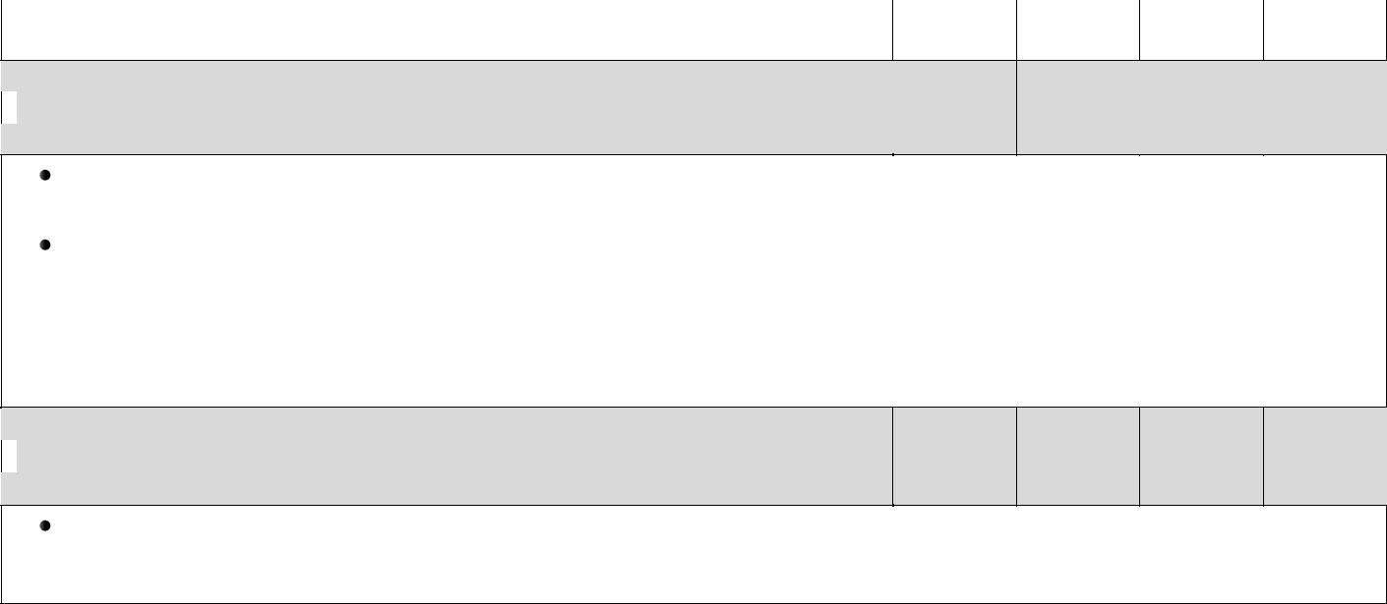
Describes and compares measurable attributes.

Describes measurable attributes of objects, such as length or weight. Describes several measurable attributes of a single object.

Directly compares two objects with a measurable attribute in common, to see which object has more of/less of the attribute, and describes the difference. For example, directly compares the heights of two children and describes one child as taller/shorter.

Classify objects and count the number of objects in each category.

Classifies objects into given categories; counts the numbers of objects in each category and sorts the categories by count.
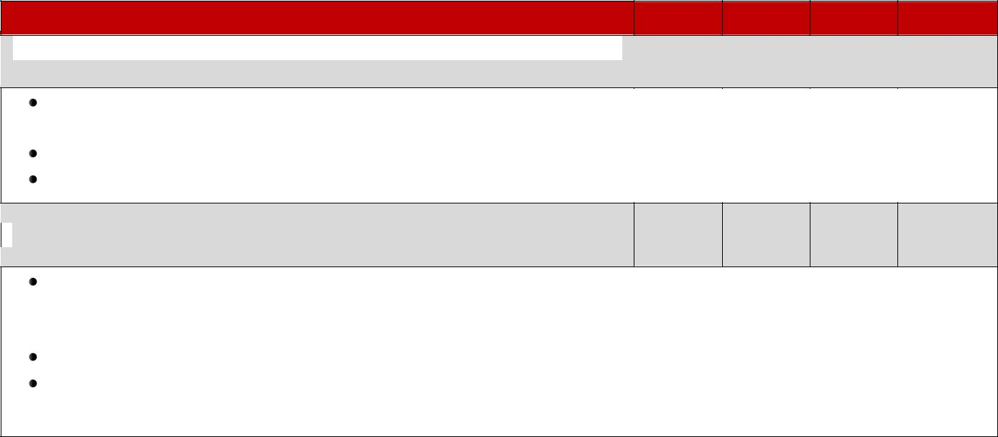

Geometry | Q1 | Q2 | Q3 | Q4
Identifies and describes shapes (squares, circles, triangles, rectangles,
hexagons, cubes, cones, cylinders, and spheres).

Describes objects in the environment using names of shapes, and describes the relative positions of these objects using terms such as above, below, beside, in front of, behind, and next to.

Correctly names shapes regardless of their orientations or overall size.

Identifies shapes as two-dimensional (lying in a plane: “flat”) or three-dimensional “solid”.

Analyzes, compares, creates, and composes shapes

Analyzes and compares two- and three-dimensional shapes, in different sizes and orientations, using informal language to describe their similarities, differences, parts (e.g., number of sides and vertices “corners” ) and other attributes (e.g., having sides of equal length).

Models shapes in the world by building shapes from components (e.g., sticks and clay balls) and drawing shapes.

Composes simple shapes to form larger shapes. For example, “Can you join these two triangles with full sides touching to make a rectangle?”
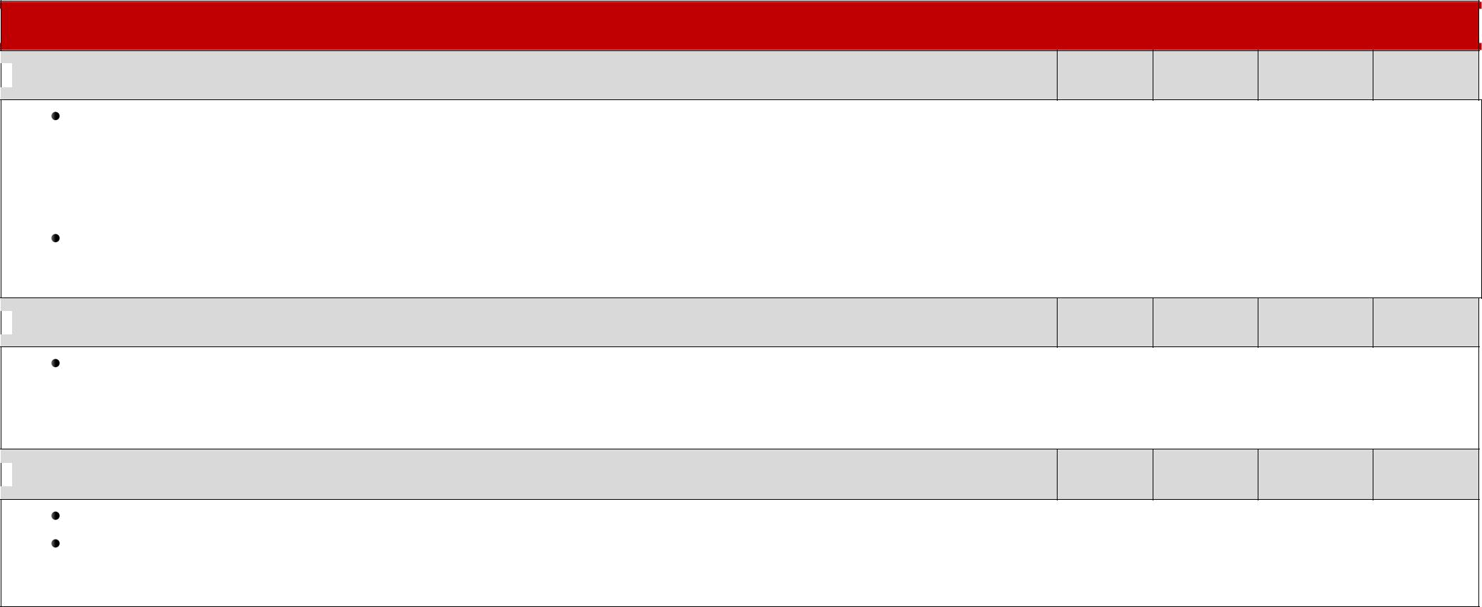
Kindergarten Science

Physical Science: Forces and Motion; Matter Properties, and Change

Understands position and motion of objects and organisms observed in the environment.

- Compare the relative position of various objects observed in the classroom and outside using position words such as: in front of, behind, between, on top of, under, above, below, and beside.
- Give examples of different ways objects and organisms move (to include falling to the ground when dropped):

  - Straight, Zigzag, Round and Round, Back and Forth, Fast and Slow

Understands how objects are described based on physical properties and how they are used.
o Classifies objects by observable physical properties (including size, color, shape, texture, weight and flexibility)
o Compares the observable physical properties of different kinds of materials (clay, wood, cloth, paper, etc.) from which objects are made and how they are used.

Earth Science: Earth Systems, Structures, and Processes

Understands change and observable patterns of weather.

o Infers that change is something that happens to many things in the environment based on observations made using one or more of their senses. o Summarizes daily weather conditions noting changes that occur from day to day and throughout the year.
o Compares weather patterns that occur from season to season.

Life Science: Structure and Functions of Living Organisms

Compares characteristics of animals and of living and nonliving things.

Compare different types of the same animal (i.e. different types of dogs, different types of cats, etc.) to determine individual differences within a particular type of animal.
- Compare characteristics of living and nonliving things in terms of their:
  - Structure, Growth, Changes, Movement, Basic Needs

