Bank Employees Pay Slip Template

How to Read your Paycheck
Pay stubs are generally divided into three sections: Employee Information, Earnings and Deductions and Paycheck Stub/Direct Deposit Advice. Our new stub follows this format. Some sections list hours and earnings that change with each pay period, while others display demographic information that may rarely change.

Employee Information
- Ministry name and address.
- The pay group, business unit, pay period begin and end date, check number and check date.
- Employee demographic data, including Employee ID, name, address and home department.
- Employee base rates are displayed. If multiple base rates apply, they will be displayed.
- Tax Data, including employee withholding elections, additional percentages and flat amounts.

Earning and Deductions
- Hours/Units and Earnings: Hours/units, rates and Year-to- Date (YTD) totals for earnings. If you exceed the number of rows available, a second paycheck/advice stub will be generated for that period.
- Taxes: Statutory tax deductions withheld from your pay for the current check and YTD earnings.
- Taxable Earnings: Taxable wages for the current period and YTD earnings are listed for each of the statutory tax categories.
- Before Tax Deductions: Current and YTD deductions that qualify under IRC Sec. 125 to be taken from pre-tax gross earnings. Includes “before tax” deductions for applicable benefit premiums, contributions to retirement plans, and/or Flexible Spending Accounts.
- After Tax Deductions: Current period and YTD deductions for items that are deducted on an after-tax basis, including certain types of benefits, cafeteria or gift shop deductions, or other deductions authorized by the employee.
- Employer Paid Benefits: Current period and YTD contributions made by the ministry towards the costs of employee benefit programs.
- Leave Balances: Leave balances and activity for the current period. 13. Totals: Current period and YTD totals for earnings, taxes, deductions and net.

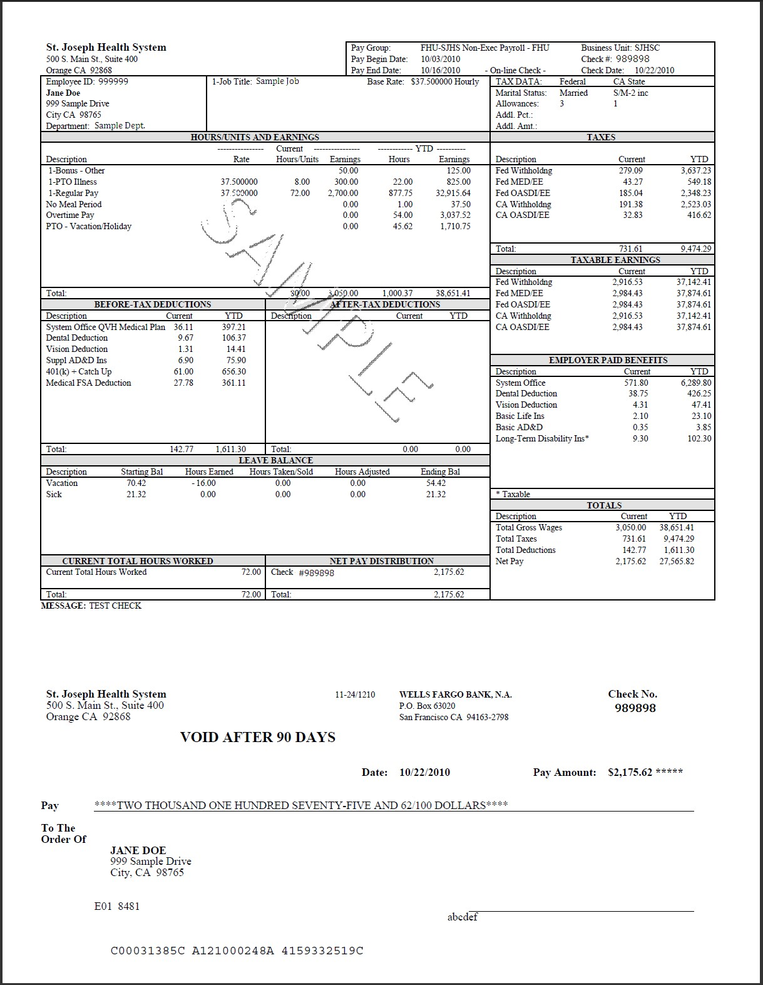
Bank Employee Pay Slip Template

E-Pay Online Earnings Statement

4
1 2

3 5

7

6

8

9

10

11

12

13
14

16

15

17

