XYZ FINANCIAL SERVICES

DIVISION OF WORKERS' COMPENSATION

BUREAU OF MONITORING AND AUDIT

SELF-INSURANCE SECTION

PAYROLL REPORT

REPORT DUE DATE

SELF-INSURER’S NAME AND ADDRESS

 | FEIN NUMBER | PERIOD COVERED
 | CARRIER NUMBER | EXPERIENCE MOD



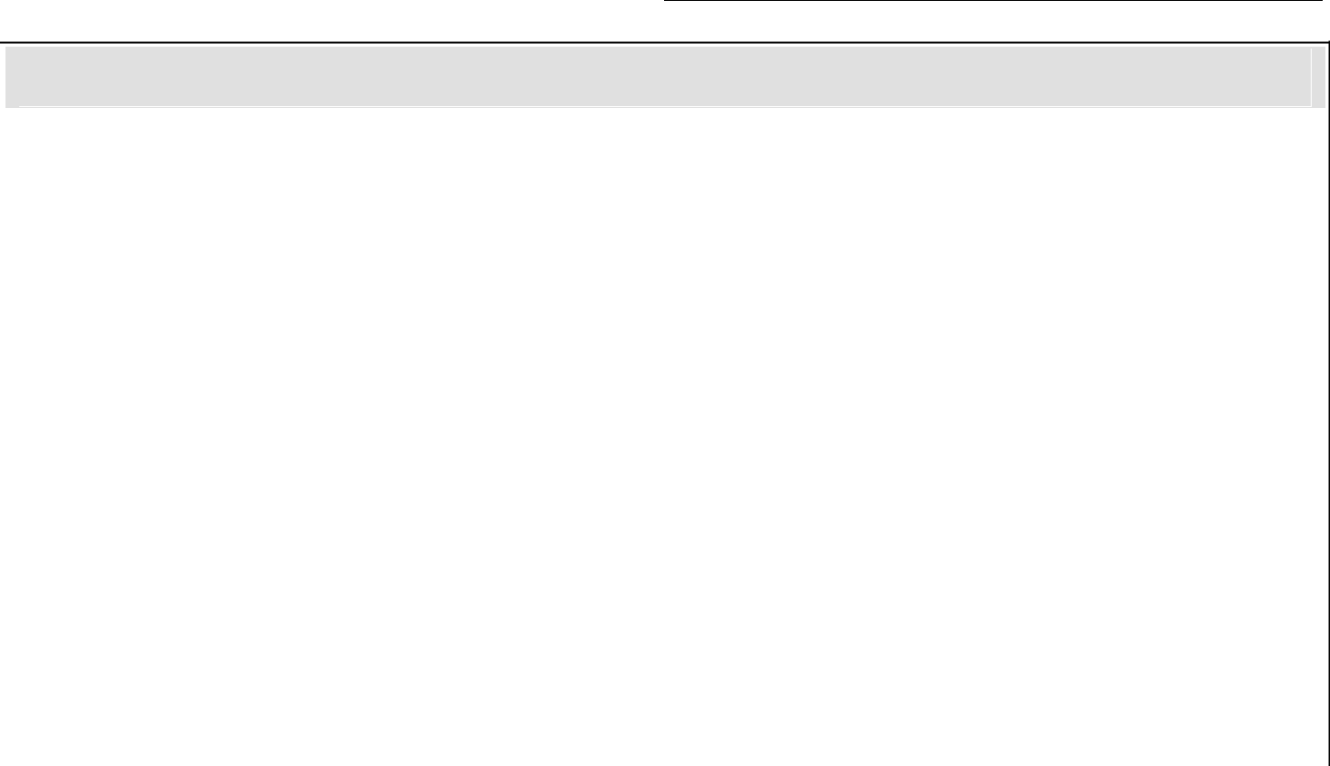

AMOUNT OF PAYROLL BY OCCUPATIONAL CLASSIFICATIONS

OCCUPATION

MANUAL

CLASS

PAYROLL*

RATE PER



$100



PREMIUM

MANUAL CLASS COLUMN– This is the 4-digit classification code number assigned to a specific type of job by the National Council on Compensation Insurance in accordance with Rule 1 of the NCCI “Basic Manual for Workers’ Compensation and Employers Liability Insurance”.

PAYROLL COLUMN – This is the total payroll paid to employees properly assigned to the classification code shown in the manual class column during the payroll period covered by this report. Payroll includes the entire remuneration, whether paid in money or a substitute for money, for services rendered by an employee and must be reported in accordance with Rule 2 of the NCCI “Basic Manual for Workers’ Compensation and Employers Liability Insurance”. Overtime payroll (in excess of 40 hours per week) should be reported at the straight time rate. Payroll for executive office should be limited to the maximum allowed by the rate filing in effect at the start of the payroll period covered.

RATE PER $100 COLUMN – This is the manual rate assigned to a specific manual class by the rate filing approved by the Dept. of Financial Services and in effect at the start of the payroll period covered.

PREMIUM – This is payroll times manual rate divided by 100.

INCLUDE EXPLANATIONS FOR CLASS CODES ADDED OR DELETED AND PAYROLL INCREASED OR DECREASED MORE THAN 20% FROM THAT REPORTED ON THE REPORT FOR THE PREVIOUS PERIOD. PERIODS OF LESS THAN A FULL YEAR SHOULD BE ANNUALIZED FOR COMPARISON PURPOSES.

FORM DFS-F2-SI-5 (8/2009)

Rule 69L-5.203, F.A.C.

