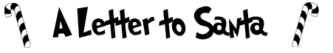
Dear Santa Claus,
Christmas is coming and I am looking forward to your visit. This year, I would like many things for Christmas:
First of all, ______________________________________
As well, __________________________________________
Finally, __________________________________________
I have been a good ________ this year, so I think I deserve these presents. Three good things I have done are:
(1) ______________________________________________
(2) _____________________________________________
(3) _____________________________________________
When you come down the chimney, please look in the kitchen. I am going to leave ________ and ________ on the table for you to have. Thank you Santa, I am very excited.
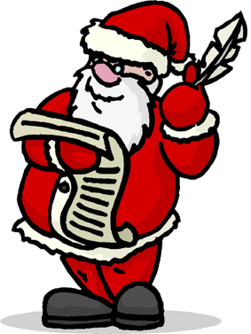 Signed _________________

