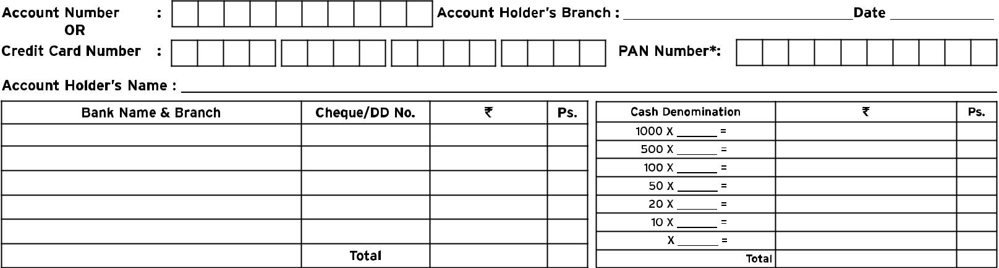
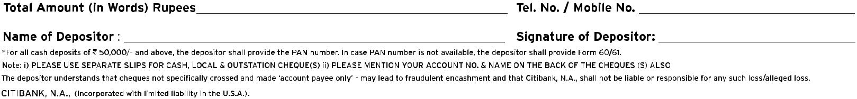
DEPOSIT SLIP TEMPLATE

