|  |  |  |  |  |
| --- | --- | --- | --- | --- |
|  | BREAKFAST | LUNCH | DINNER | SNACK |
| **SUNDAY** |  |  |  |  |
| **MONDAY** |  |  |  |  |
| **TUESDAY** |  |  |  |  |
| **WEDNESDAY** |  |  |  |  |
| **THURSDAY** |  |  |  |  |
| **FRIDAY** |  |  |  |  |
| **SATURDAY** |  |  |  |  |
|  |  |  |  |  |

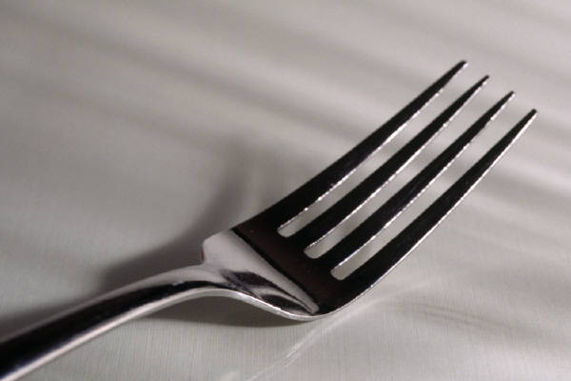

**WEEKLY MEAL PLANNER**