WEEKLY PAYROLL REPORT

(Attach insurance premium payment to Report and forward to council/district PTA as directed by
Their deadline date. Payment must be received from district PTA on or before January 31)

Name of PTA ____________________________________________________________ District ________________

Address ________________________________________________________________ Council ________________

City __________________________________________________________________ Zip ________________

Please note: List only those payees that PTA pays directly for services. Do NOT list payees when monies are donated to a school district to pay workers.

 |  |  |  |  |  |  |  | DOES THE PAYEE CARRY |  |  | DATES WORKED
 |  |  |  |  |  |  |  | THEIR OWN WORKERS’ |  |  | (DATE____ TO |  | AMOUNT
 | NAME OF PAYEE |  |  | TYPE OF WORK |  |  | COMPENSATION INSURANCE? |  |  |  | (DATE____ TO |  | PAID FOR
 | NAME OF PAYEE |  |  | TYPE OF WORK |  |  |  |  |  |  | DATE____) |  | PAID FOR
 | (INDIVIDUAL OR ORGANIZATION) |  |  | (BE SPECIFIC) |  |  |  | YES* | NO |  | DATE____) |  | SERVICES
1
2
3
4
5
6
7
8
9
10
11
12
A |  |  |  |  |  |  |  |  |  | Total for ALL Payees
B |  |  |  |  |  |  |  |  |  |  | Less $1,000
C |  |  |  |  |  |  |  |  |  |  | Gross Pay
D | Premium due for additional Workers’ Compensation insurance coverage. 5% of Gross Pay (Line C)

- If “yes”, the payee must provide a Certificate of Insurance from their Workers’ Compensation insurance carrier to the PTA. The Certificate must list limits in the Workers’ Compensation section and be attached to this report form. Please note, General Liability insurance is NOT Workers’ Compensation insurance.

This report form must be completed and forwarded through channels to reach the California State PTA office no later than January 31.

- Unit, council and district PTAs are required to file this form, even if no one was paid.

- Report ALL payees PTA paid directly for services – attach additional Payroll Report detail pages(s) as necessary.

- Write “NO ONE PAID” across form if no one was paid.

- Signed by treasurer or president.

- Forward through channels (unit to council to district). DO NOT send directly to the California State PTA office.

- Insurance premium received in the California State PTA office after January 31 is subject to a $25 late fee by State PTA.

- See California State PTA Toolkit, “Workers’ Compensation Annual Report,” for more information.

Date _________________________ |  |  |  | Signed _______________________________________________________________________
Phone (_______)_______________________ |  |  |  |  | Position ______________________________________________________________
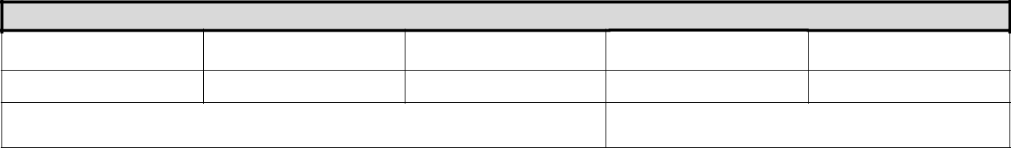

FOR COUNCIL/DISTRICT PTA USE ONLY

PAYMENT DATE

CHECK NUMBER

AMOUNT OF CHECK

TOTAL ADDITIONAL

PREMIUM (LINE D)

AMOUNT DUE

SIGNATURE (Council/district PTA president or treasurer):

