

MONTH:

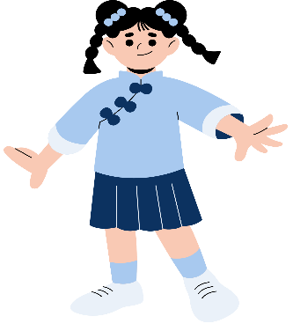

Newsletter

ELEMENTARY

WHAT WE'RE LEARNING

PARENT CORNER

STUDENT ACHIEVEMENTS

UPCOMING EVENT