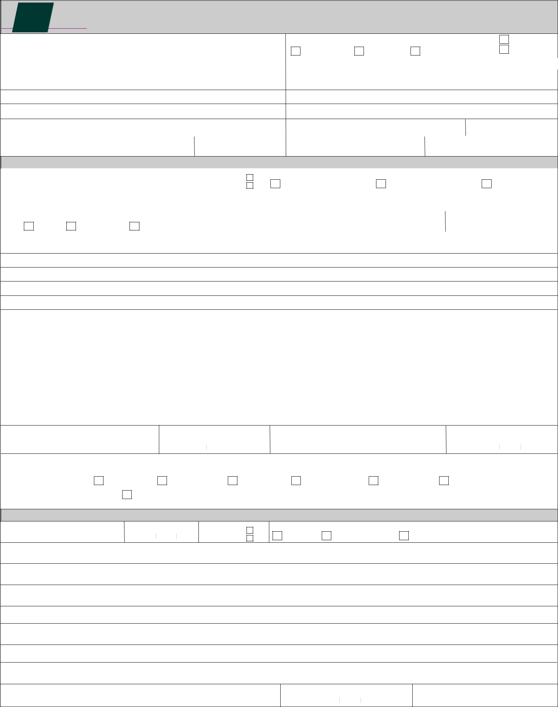

INSURANCE REINSTATEMENT REQUEST

INSURANCE COMPANY POLICY NUMBER

DIRECT BILL

COMPANY BILL

AGENCY BILL

PERSONAL

COMMERCIAL

INSURED’S FULL NAME AND POSTAL ADDRESS |  | BROKER’S FULL NAME AND POSTAL ADDRESS
FIRST NAME | MIDDLE NAME | LAST NAME

 | POSTAL
 | CODE
COMPANY CUSTOMER ID: | BROKER’S CLIENT ID:
POSTAL
CODE

CANCELLATION REQUEST

 |  | CANCELLATION DATE |  |  |  |  |  | TIME |  |  |  | AM |  | REASON FOR CANCELLATION
EFFECTIVE DATE AND HOUR OF CANCELLATION |  |  |  |  |  |  |  |  | : |  |  | AM
 |  | YYYY |  | MM |  |  | DD |  | : |  |  | PM | REQUESTED BY INSURED | REWRITTEN (Complete below) |  | OTHER (State in REMARKS)
 |  | EFFECTIVE DATE |  |  |  |  |  | EXPIRATION DATE |  |  |  |  | COMPANY
POLICY TERM |  | YYYY |  | MM |  |  | DD | YYYY |  | MM |  | DD
 | METHOD OF CANCELLATION |  |  |  |  |  |  | PREMIUM PAID TO BROKER |  |  |  |  | POLICY NUMBER | EXPIRATION DATE
FLAT | SHORT RATE | PRO RATA |  |  |  |  |  | $ |  |  |  |  |  | YYYY |  | MM |  | DD

REMARKS:

CANCELLATION STATEMENT

This release must be signed by all with a financial interest in the policy.

I / We agree that the policy indicated by number (above) together with any renewal certificates relating thereto are cancelled as of the date stated above and that the Insurer is relieved from all liability thereunder from said date.

Any premium adjustment will be made in accordance with the terms and conditions of the policy.

WARNING - Any person who issues or produces a card to show that there is in force a policy of insurance as indicated herein that is in fact not in force is liable to a heavy fine and/or imprisonment and their licence may be suspended.

SIGNATURE OF NAMED INSURED

DATE

YYYY

 | SIGNATURE OF NAMED INSURED | DATE
 |  | YYYY
MM | DD | YYYY

MM DD

RELEASE(s) ATTACHED

INSURED

MORTGAGEE

LIENHOLDER

FINANCE COMPANY

LOSS PAYEE

LESSOR

WHERE RELEASES ARE NOT ATTACHED, PLEASE ISSUE CANCELLATION NOTICES TO ALL INTERESTS ON THE CANCELLED POLICY.
REINSTATEMENT REQUEST

REINSTATEMENT DATE
EFFECTIVE DATE AND HOUR OF REINSTATEMENT
YYYY MM DD

TIME

:

AM

PM

FULL

 | PAYMENT RECEIVED
CERTIFIED CHEQUE | PARTIAL | BALANCE OWING $___________________

REASON FOR REINSTATEMENT:

BROKER / AGENT SIGNATURE

DATE

.

