PARTY NAME HERE
Reduce or Cancel Insurance Cove

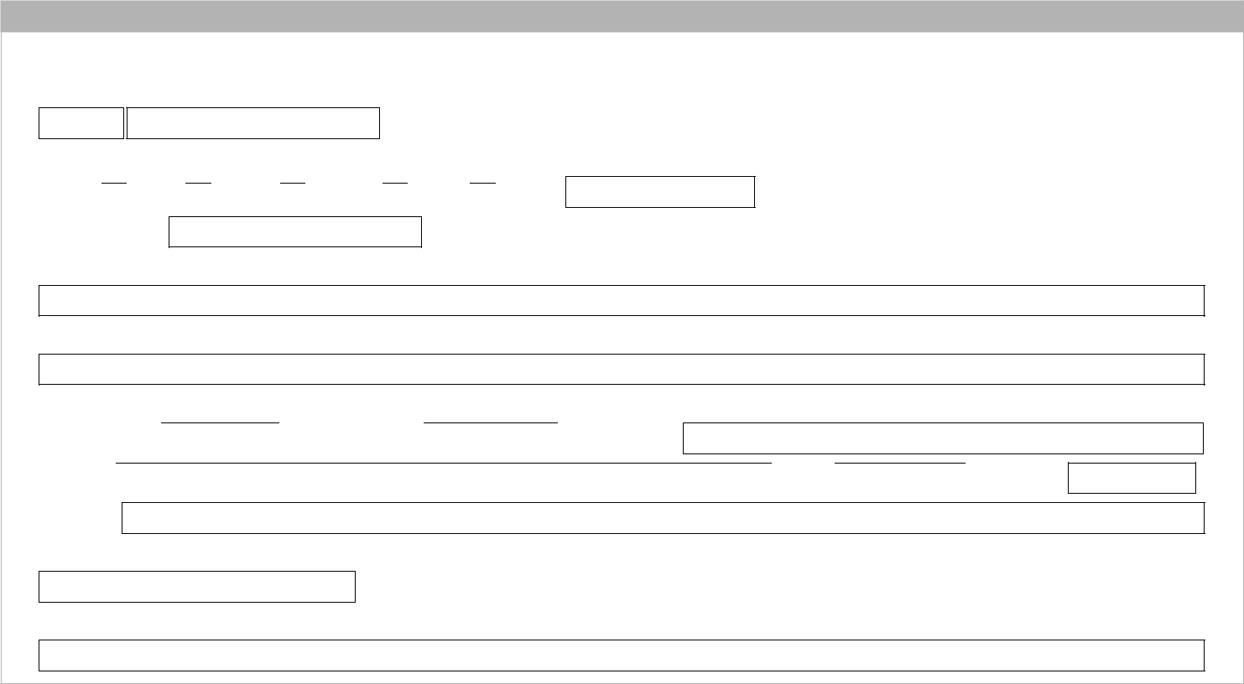

1 Account details

Fields marked with an asterisk (*) must be completed

Essential Super account number*

If you do not know your account number, please fill in your details below.

Title Mr Mrs Miss Ms

Date of birth*

Given name(s)*

Other

Surname*

Postal address

Unit number  Street number  Street name

Suburb State  Postcode

Country

Daytime phone number

Email address


2 Reduce insurance cover

I request you to reduce my Death and/or Total and Permanent Disablement (TPD) cover to the cover nominated below

Half default cover

Default cover (this option is only available to members who have double the default amount of cover)

Note: When reducing cover you have options. If you currently have default cover, you can request to halve your default cover. If you currently have double the default cover, you can reduce to either default cover or half default cover.


3 Cancel insurance cover

I request you to cancel my insurance cover selected below:

Death and Total and Permanent Disablement (TPD) cover

Total and Permanent Disablement (TPD) cover Only

Note: When cancelling cover it is recommended that you do not cancel existing cover until any replacement cover you are arranging is in place.

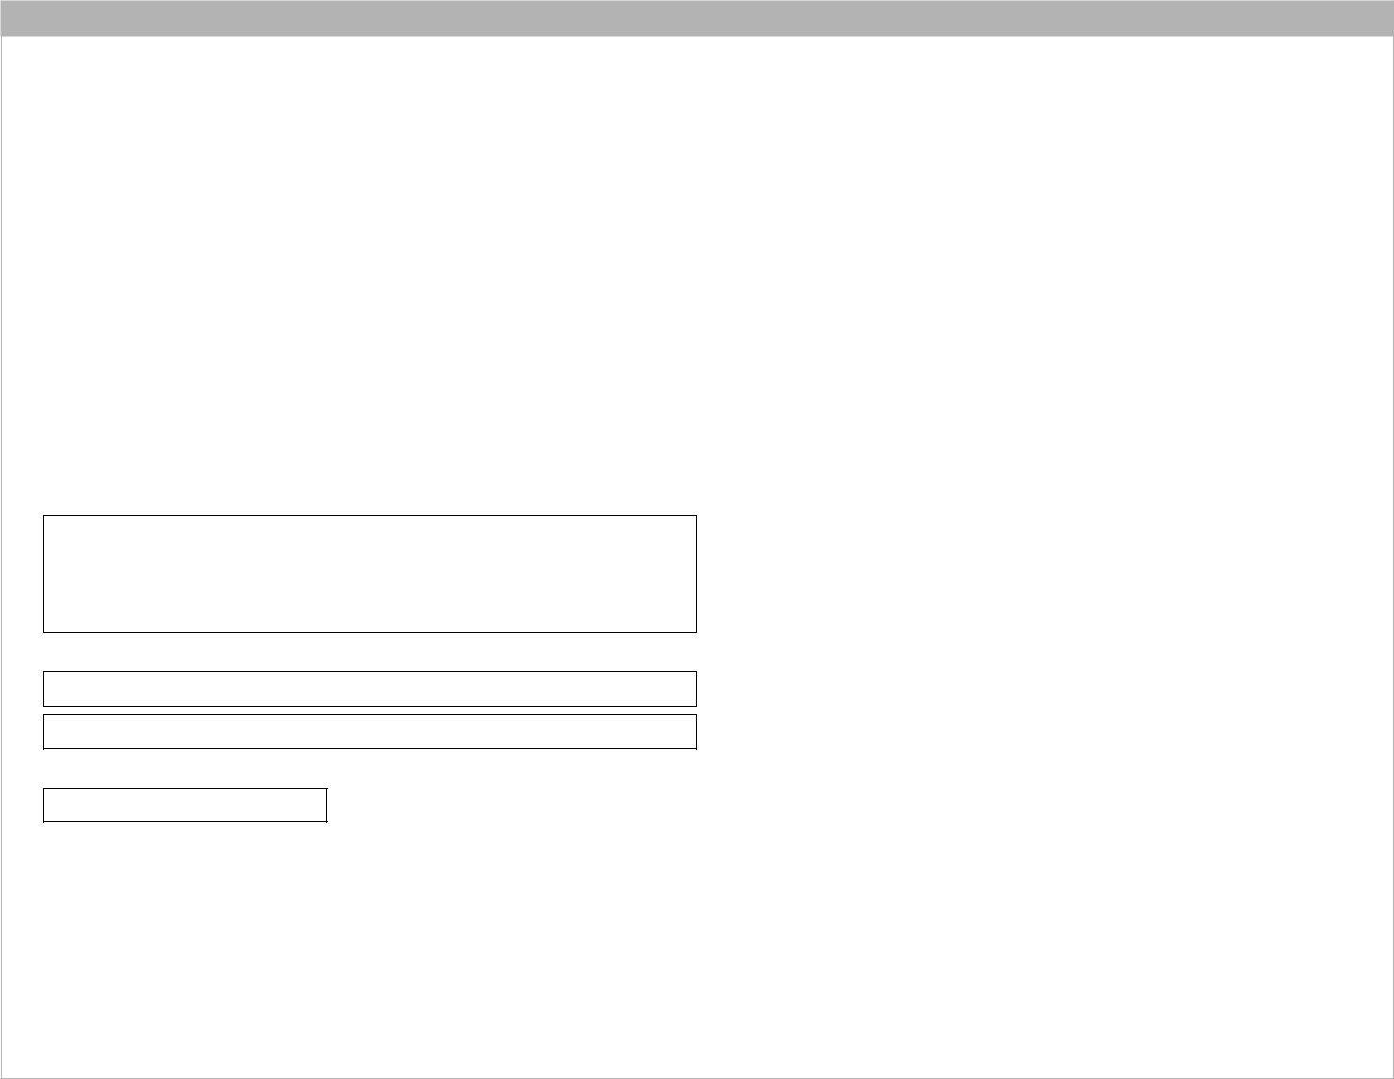
4 Declaration

If I have requested that my cover be reduced or I have requested that some, but not all, of my cover be cancelled, I understand that:

- the cost of my cover may change in accordance with the insurance policy terms

- I can cancel or reduce my cover at any time

- my insurance cover may end in circumstances set out in the Product Disclosure Statement and Reference Guide (for example

if there are insufficient funds in my account to meet insurance premiums)

- by keeping the insurance cover, future premiums will continue to be deducted from my account and may reduce my super.

If I have requested that any of my cover be cancelled, I understand that:

- I will no longer have insurance premiums deducted from my super account for cover that I have cancelled

- I won’t be able to claim for any insured events that occur after my cover is cancelled (but I will be able to make a claim for any insured events that occurred before my cover is cancelled)

- if I want insurance cover in the future, I will need to complete a new insurance application and provide information about my medical history. I understand that the insurer may accept or decline my application.

Signature of member

✗

Print name

Date signed

DD/MM/YYYY

If this form is signed under Power of Attorney, the Attorney declares that they have not received a notice of revocation of that power (a certified copy of the Power of Attorney should be submitted with this form unless we have already sighted it)

We recommend you review your insurance arrangements regularly and seek financial advice before you apply to cancel

or reduce your cover. For general information about insurance in super please read the Essential Super Reference Guide available at www.commbank.com.au/super

