
Cancellation

Request Form

Not all contacts are cancellable/refundable. See contract for full terms and conditions.

The items below marked with an asterisk (*) are required to be completed in order to process the cancellation.

Customer
CUSTOMER’S NAME* |  | CO-CUSTOMER’S NAME |  |  |  | CONTRACT NUMBER*
PHONE NUMBER | EMAIL ADDRESS
STREET ADDRESS* |  |  | CITY* |  | STATE* | ZIP*

Vehicle

YEAR

MAKE

MODEL

VIN*
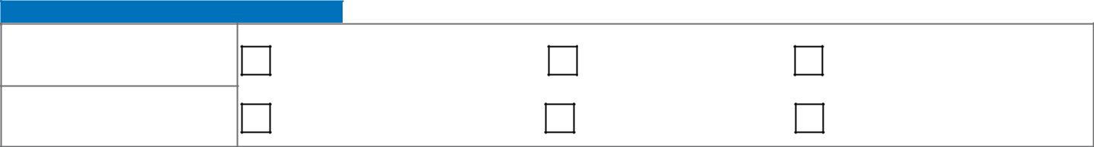

Cancel Information

CANCELLATION ODOMETER*

CANCELLATION DATE*

REASON FOR CANCELLATION (SELECT ONLY ONE):

VEHICLE TRADED IN

REPOSSESSION

TOTAL LOSS

VEHICLE SOLD

LOAN PAID IN FULL

CUSTOMER DECIDED AGAINST

Refund Recipient

SELECT ONLY ONE AND COMPLETE THE ITEMS TO THE RIGHT OF THE SELECTED RECIPIENT. * Unless proof of Vehicle payoff is provided, the refund will be paid to the Lienholder.

 |  |  | LIENHOLDER NAME |  | LOAN ACCOUNT NUMBER
REFUND TO LIENHOLDER
REFUND TO LIENHOLDER |  |  | STREET ADDRESS | CITY |  | STATE | ZIP
 |  |  | YOU MUST PROVIDE A COPY OF:
REFUND TO SELLER |  |  | Buyer’s Order or Odometer Statement
REFUND TO SELLER |  |  | Proof of Payoff to Lienholder
 |  |  | Other Documentation May Be Requested by Cancellation Department
 |  |  | YOU MUST PROVIDE PROOF OF PAYOFF BY:
REFUND TO CUSTOMER |  |  | Copy of Lien Release, Clear Title Showing Lien Release, or Payoff Letter from Original Lender/Lessor
REFUND TO CUSTOMER |  |  | Other Documentation May Be Requested by Cancellation Department

Customer’s Signature* Date*

Submit all required documents with this f

