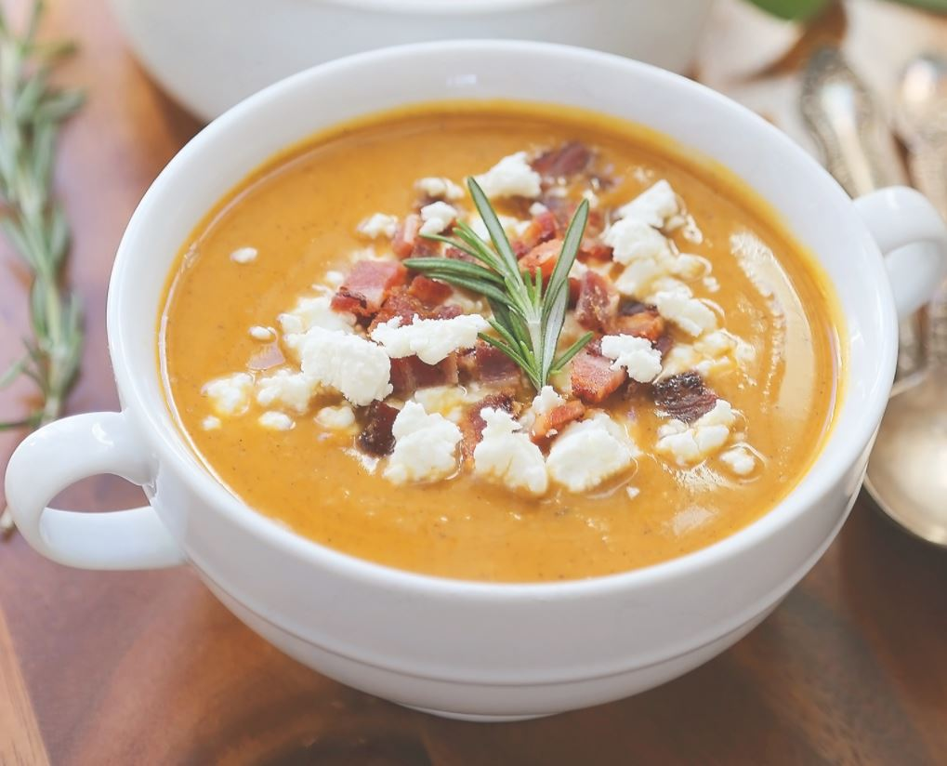Cookbook Template

**SERVINGS**

**PREP**

**COOK**

**DIFFICULTY**

Vegetable Soup

**DIRECTIONS**

**INGREDIENTS**

**1 large onion**

**4-5 medium carrots, peeled**

**4 celery sticks**

**1 tablespoon olive oil**

**Salt**

**1 teaspoon crushed red pepper flakes**

**1 pound thin-skinned potatoes**

**3 garlic cloves, peeled and halved**

**3 cups chicken or vegetable stock**

**2 bay leaves**

**3 sprigs fresh thyme**

**1/4 cup coconut milk**

**Chop carrots, onion, and celery into 1/2-inch chunks. Chop the potatoes into 1/2-inch chunks, but set aside from other vegetables.**

**Lorem ipsum dolor sit amet, consectetuer adipiscing elit. Maecenas porttitor congue massa. Fusce posuere, magna sed pulvinar ultricies, purus lectus malesuada libero, sit amet commodo magna eros quis urna.**

**Nunc viverra imperdiet enim. Fusce est. Vivamus a tellus.**