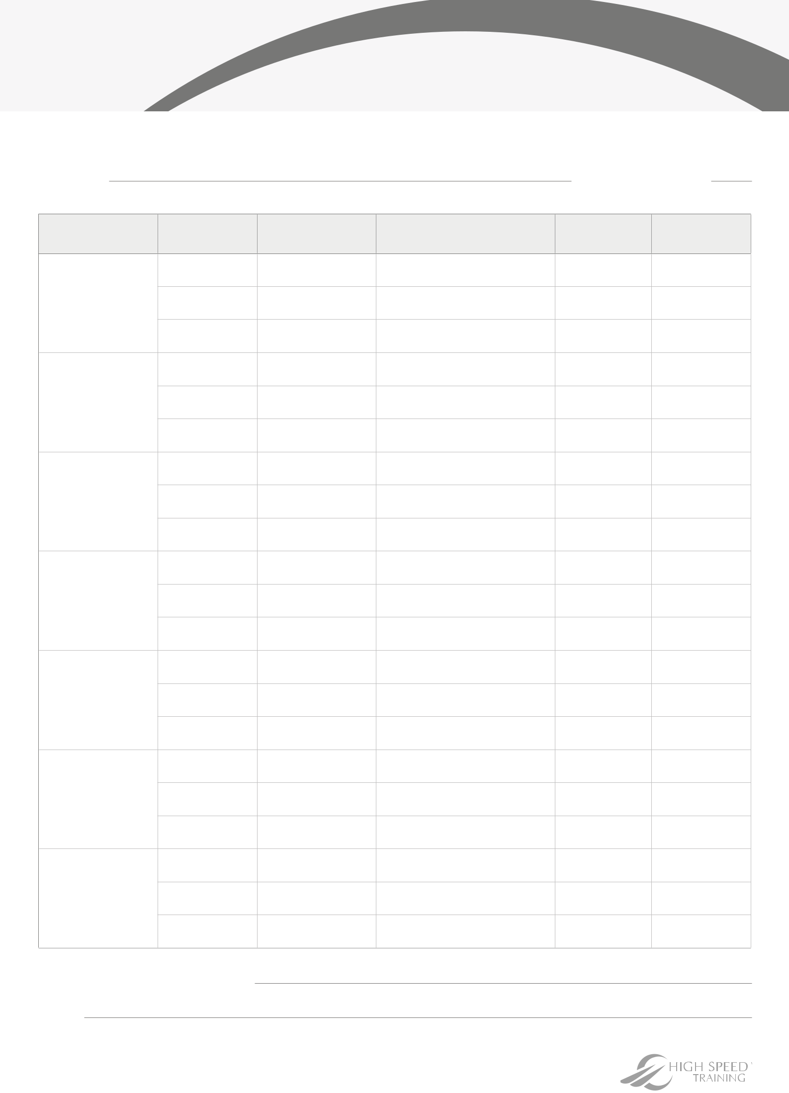
Freezer Temperature Record Sheet

Ideal temperature: -18°C

Location: Cabinet number:

DATE

TIME

TEMPERATURE

ACTION

INITIALS

SUPERVISOR

Monday

(DD/MM/YY)

Tuesday

(DD/MM/YY)

Wednesday

(DD/MM/YY)

Thursday

(DD/MM/YY)

Friday

(DD/MM/YY)

Saturday

(DD/MM/YY)

Sunday

(DD/MM/YY)

Completed sheet verified by:

Date:

