Vaccine Storage Temperature Log (Celsius)

Location of unit:_ ______________________Month/Year:_____________________________

Site name:____________________________PIN:____________________________________

- Check and document temperatures every day site is open. Complete this log with:

3 Time of day and initials of the staff person recording the temperatures.

3 Minimum (lowest) temperature and maximum (highest) temperature once a day, in the morning before using the vaccine.
3 Current temperature, twice a day.

–– Mark “X” in the box with the current temperature.

–– If the temperature is too warm or too cold, write the actual temperature in the shaded box, do not use “X.”

3 Write “closed” for days when the site is not open.

- Take immediate action on any out of range temperatures, including minimum and maximum temperatures.
3 Stop using vaccine and and mark it “Do Not Use.”

Note: If the vaccine has gotten too warm or too cold, you will not be able to distinguish viable from nonviable vaccine by looking at it.
3 Document the details of the temperature excursion.

3 Contact manufacturers and MDH for guidance.

3 Correct the problem.

- Review readings weekly for out-of-range temperatures or temperature trends.

- Keep monthly temperature logs for three years with your vaccine records.

Days 1-15
Day of Month | Example |  | 1 | 2 |  | 3 |  | 4 |  | 5 | 6 | 7 | 8 |  | 9 |  | 10 |  | 11 | 12 |  | 13 |  | 14 |  | 15
Time | am | pm | ampm | am | pm | am | pm | ampm | am | pm | ampm | ampm | am | pm | am | pm | ampm | am | pm | am | pm | am | pm | am | pm | ampm
Time | 800 | 315
of day | 800 | 315
Staff Initials | SK | JM

Refrigerator - Store vaccine at 2°C – 8°C |  |  |  |  |  |  | Aim for 5°C
Min/Max | 6°/8° |  | / | / | / | / | / | / | / | / | / | / | / | / | / | / | /
9° or warmer |  |  |  |  |  |  |  |  | Too warm!
8°
7° | X | X
6°
5°
4°
3°
2° |  |  |  |  |  |  |  |  | Too cold!
1° or colder |  |  |  |  |  |  |  |  | Too cold!
Freezer - Store vaccine at -15°C or colder |  |  |  |  |  |  | Aim for -18°C
Min/Max -16° / -15° |  |  | / | / | / | / | / | / | / | / | / | / | / | / | / | / | /
-14° or warmer |  |  |  |  |  |  |  |  | Too warm!
-15°
-16° | X | X
-17°
OTHER |  |  |  |  |  |  |  |  | Too cold!
-50° or colder |  |  |  |  |  |  |  |  | Too cold!
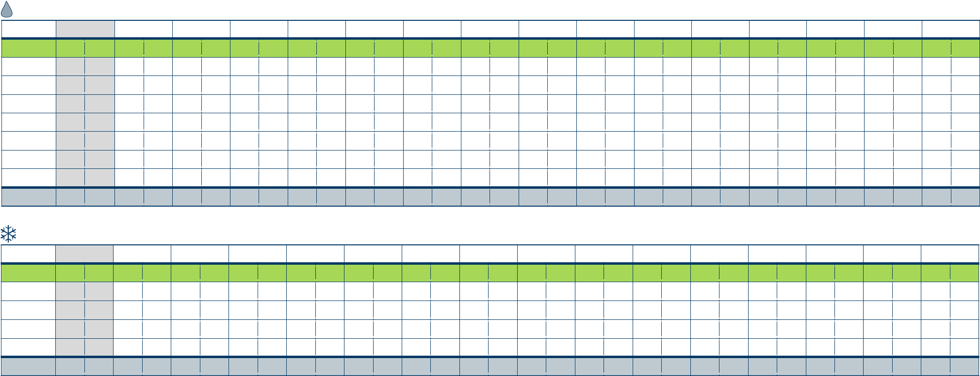

)


Vaccine Storage Temperature Log (Celsius)

Location of unit:_ ______________________Month/Year:_____________________________

Site name:____________________________PIN:____________________________________

- Check and document temperatures every day site is open. Complete this log with:

3 Time of day and initials of the staff person recording the temperatures.

3 Minimum (lowest) temperature and maximum (highest) temperature once a day, in the morning before using the vaccine.
3 Current temperature, twice a day.

–– Mark “X” in the box with the current temperature.

–– If the temperature is too warm or too cold, write the actual temperature in the shaded box, do not use “X.”

3 Write “closed” for days when the site is not open.

- Take immediate action on any out of range temperatures, including minimum and maximum temperatures.
3 Stop using vaccine and and mark it “Do Not Use.”

Note: If the vaccine has gotten too warm or too cold, you will not be able to distinguish viable from nonviable vaccine by looking at it.
3 Document the details of the temperature excursion.

3 Contact manufacturers and MDH for guidance.

3 Correct the problem.

- Review readings weekly for out-of-range temperatures or temperature trends.

- Keep monthly temperature logs for three years with your vaccine records.

Days 16-31
Day of Month |  | 16 | 17 |  | 18 |  | 19 | 20 | 21 |  | 22 |  | 23 |  | 24 | 25 |  | 26 |  | 27 |  | 28 |  | 29 | 30 |  | 31
Time | am | pm | am | pm | am | pm | ampm | ampm | am | pm | am | pm | am | pm | ampm | am | pm | am | pm | am | pm | am | pm | ampm | am | pm | ampm
of day
Staff Initials

Refrigerator - Store vaccine at 2°C – 8°C |  |  |  |  |  | Aim for 5°C
Min/Max | / | / | / | / | / | / | / | / | / | / | / | / | / | / | / | /
9° or warmer |  |  |  |  |  |  |  | Too warm!
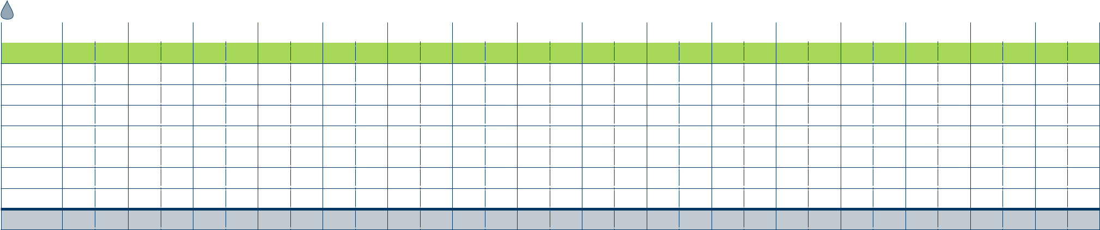
8°

7°

6°

5°

4°

3°

2°

1° or colder | Too cold!

Freezer - Store vaccine at -15°C or colder |  |  |  |  |  | Aim for -18°C
Min/Max | / | / | / | / | / | / | / | / | / | / | / | / | / | / | / | /
-14° or warmer |  |  |  |  |  |  |  | Too warm!
-15°
-16°
-17°
OTHER
-50° or colder |  |  |  |  |  |  |  | Too cold!
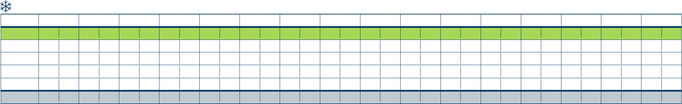

Page 2 of 2

Time to reorder Vaccine Storage Temperature Logs

Mail:

Phone:

Fax:

Agency

Address

City | State | Zip
Phone | Contact name


Amount Limit Vaccine Storage Temperature Log

- Logs are free of charge

ID#

- Vaccine Storage Temperature Logs are also available to download from the web at www.health.state.mn.us/immunize

