 | SUMMIT FREIGHT & LOGISTICS INC. |  |  |  |  |  | DRIVING LOG SHEET
 | 1420 Westport Avenue • Kansas City, MO 64111 • Tel: (816) 555-7823 |  |  |  |  |  |  |  |  |  |  |  | April 30, 2026
 |  |  |  |  |  |  |  |  |  |  |  |  |  |  |  | 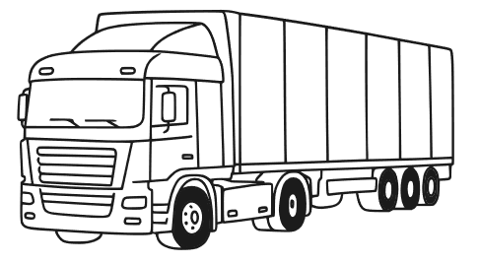
 | This log sheet records service-based driving activities for assigned clients. All entries must be completed daily and verified by the driver and supervisor. Accurate documentation ensures accountability, supports operational planning, and helps maintain compliance with company and regulatory standards.
 | Vehicle | Date | Area | Start  Mileage |  | End  Mileage |  | Start  Time |  | End  Time |  | Client |  |  |  | Vehicle  Inspection |  | Client  Signature |  | Paperwork  Submitted
 | Freightliner Cascadia 116 (GL-186372) | 4/2/2026 | Rockville – Washington, DC | 124,498 |  | 125,020 |  | 09:00 |  | 16:15 |  | MGO Logistics |  |  |  | ✔ |  | ✔ |  | ✔
 | Peterbilt 389 (DL-335379) | 4/3/2026 | Montgomery – Norwalk | 56,454 |  | 57,332 |  | 08:15 |  | 17:45 |  | Delta Distribution |  |  |  | ✔ |  | ✔ |  | ✔
 | Mack Pinnacle CXU613 (GL-627118) | 4/4/2026 | Greenfield – Wheaton | 82,050 |  | 82,915 |  | 07:45 |  | 15:50 |  | Johnson Materials |  |  |  | ✔ |  | ✔ |  | ✔
 | Freightliner Cascadia 116 (GL-186372) | 4/5/2026 | Winchester – Springfield | 125,020 |  | 125,583 |  | 08:00 |  | 18:15 |  | Fenworth Hardware |  |  |  | ✔ |  | ✔ |  | ✔
 | NOTES |  |  |  |  | DRIVER'S SIGNATURE |  |  |  |  |  |  |  | SUPERVISOR'S SIGNATURE
 | All four trips were completed without delays or incidents. Vehicle inspections were performed daily, and all client signatures and documentation were collected as required. Driver rotated between three fleet vehicles based on availability and route assignment.

